**HCMC UNIVERSITY OF TECHNOLOGY AND EDUCATION**

**FACULTY OF INFORMATION TECHNOLOGY**



**Project on Software Engineering**

**STUDY DEEP LEARNING BASED ACTION RECOGNITION**

**Lecturer name**: Assoc. Prof. Hoang Van Dung

**Members:**

Đỗ Trần Công Phương 19110133

Nguyễn Nhiêu Thịnh 19110003

*Ho Chi Minh City, 12/2022*

**HCMC UNIVERSITY OF TECHNOLOGY AND EDUCATION**

**FACULTY OF INFORMATION TECHNOLOGY**



**Project on Software Engineering**

**STUDY DEEP LEARNING BASED ACTION RECOGNITION**

**Lecturer name**: Assoc. Prof. Hoang Van Dung

**Members:**

Đỗ Trần Công Phương 19110133

Nguyễn Nhiêu Thịnh 19110003

*Ho Chi Minh City, 12/2022*

**COMMENTS FROM THE INSTRUCTOR**

*Ho Chi Minh City, 12/2022*

INSTRUCTOR

# 

# ACKNOWLEDGMENT

We would like to express our gratitude to the instructor, Hoang Van Dung, for his direct assistance throughout the process, which enabled us to complete this thesis and report successfully. We appreciate your practical guidance in orienting us in accordance with the requirements of the chosen topic, as well as your constant availability to answer questions and provide recommendations and corrections in a timely manner to assist us in overcoming shortcomings, scoring well, and finishing on time.

We'd also like to thank the faculty members of the Faculty of Education High Quality in general, and the Information Technology industry in particular, for enthusiastically passing on the necessary knowledge to help us lay a foundation for this topic and creating conditions for us to learn and perform well on it. With that, we'd like to thank my classmates for providing us with a lot of useful information and knowledge to aid us in improving our topic.

We finish subjects and reports in a short amount of time, with limited expertise and a variety of other constraints in terms of techniques and software project execution experience. As a result, there are problems in the topic development process. Although omissions are unavoidable, dear teachers, we would appreciate hearing from you so that we can enhance our knowledge and perform better next time. Thank you so much for everything. Finally, we wish you and your teachers continued good health and success in your teaching professions. Thank you so much once more.

# PREFACE

The purpose and objective of this training, as well as the majority of the content, is to save time, and we have earned some confidence in launching the application as a result of this training. We also feel that we have acquired some IT knowledge, and that with enough practice and expertise in the subject, we will be able to thrive in today's competitive climate.

The effort put forth to prepare the report is only a portion of what is required to complete the course. In the report, I make every effort to provide all of the knowledge that we learnt in the program in a logical and presentable manner. To portray the complete topic more prominently and clearly, I grouped each of the topics into individual chapters. I used the citation method throughout the report as a reference. Finally, I am optimistic that the report's structure and content will be beneficial information for all readers, particularly the user.

# TASK ASSIGNMENT

|  |  |
| --- | --- |
| **Name** | **Task work** |
| Đỗ Trần Công Phương | Creating data, build and train Sequential model |
| Nguyễn Nhiêu Thịnh | Searching and using MediaPipe holistic, use model to create application |

# **TABLE OF CONTENT**

ACKNOWLEDGMENT 4

PREFACE 5

TASK ASSIGNMENT 6

TABLE OF CONTENT 7

TABLE OF FIGURE 10

TABLE OF ACRONYMS 12

CHAPTER 1. OVERVIEW 13

1.1. Objectives 13

1.2. Target 13

1.3. Scope and audience 13

CHAPTER 2. THEORETICAL BACKGROUND 14

2.1. Machine Learning 14

2.1.1. Introduction 14

2.1.2. Theory. 15

2.1.3. Approaches 16

2.1.4. Machine learning Workflow 19

2.1.5. Some basic concepts 20

2.2. Deep learning 22

2.2.1. Introduction Machine Learning 22

2.2.2. Neural networks 24

2.2.3. Applications 26

2.3. Tools and environments for programming 31

2.3.1. Visual Studio Code 31

2.3.2. Python programming language 31

2.3.3. Keras 32

2.3.4. Sklearn library 33

2.3.5. MediaPipe Holistic 34

CHAPTER 3. DESIGN SIGN-LANGUAGE RECOGNITION APP FOR THE ALPHABET 39

3.1. Collecting data, building and training model 39

3.1.1. Detect Face, Hand and Pose Landmarks 39

3.1.2. Extract Keypoints 40

3.1.3. Setup Folders for Data Collection 41

3.1.4. Collect Keypoint Sequences 41

3.1.5. Preprocess Data and Create Labels 43

3.1.6. Build and Train an LSTM Deep Learning Model 44

3.1.7. Make Sign Language Predictions 44

3.1.8. Evaluation using a Confusion Matrix 44

3.2. Build Sign-language Recognition Application 46

3.2.1. Idea 46

3.2.2. Build Application 47

CHAPTER 4. EXPERIMENT AND ANALYSIS 53

4.1. Libraries and data collection: 53

4.2. Training result 56

4.3. Evaluation using Confusion Matrix and Accuracy 58

4.4. Testing model 59

4.5. Testing the application 61

CHAPTER 5. CONCLUSION 72

5.1. Evaluate project 72

5.1.1. Advantages: 72

5.1.2. Limitations: 72

5.1.3. Development orientation 72

REFERENCES 73

# TABLE OF FIGURE

Figure 2‑1 MediaPipe Holistic model 35

Figure 3‑1 MediaPipe 39

Figure 3‑2 Detect Face, Hand and Pose Landmarks 39

Figure 3‑3 Draw landmark 40

Figure 3‑4 Result of draw landmark 40

Figure 3‑5 Store key points in Numpy Array 41

Figure 3‑6 Setup Folders for Data Collection 41

Figure 3‑7 Start Collecting data 42

Figure 3‑8 Collection function 43

Figure 3‑9 Data loading code 43

Figure 3‑10 Model definition 44

Figure 3‑11 Match result with action 44

Figure 3‑12 Evaluate the model 45

Figure 3‑13 Testing function 46

Figure 3‑14 Camera detection 48

Figure 3‑15 The action for the letter M 49

Figure 3‑16 Build window application 50

Figure 3‑17 Build probably button 50

Figure 3‑18 Ressult of Problist 50

Figure 3‑19 Result Area 51

Figure 3‑20 Code of result Area 51

Figure 3‑21 Logic show action 52

Figure 4‑1 MP_data 54

Figure 4‑2 Data set of an action 55

Figure 4‑3 Dataset of a video 55

Figure 4‑4 Code to load data 56

Figure 4‑5 Compile and Fit model 56

Figure 4‑6 Steps training model 56

Figure 4‑7 The prossess training model 57

Figure 4‑8 Epoch_categorical_accuracy 57

Figure 4‑9 Epoch_loss 57

Figure 4‑10 Chart showing model summary 58

Figure 4‑11 Result after training 58

Figure 4‑12 Evaluation using Confusion Matrix and Accuracy 58

Figure 4‑13 Confusion matrix 59

Figure 4‑14 Accuracy_score 59

Figure 4‑15 Test model effect 60

Figure 4‑16 Prediction code 60

Figure 4‑17 Action A 61

Figure 4‑18 Action B 61

Figure 4‑19 Action C 62

Figure 4‑20 Action D 62

Figure 4‑21 Action E 63

Figure 4‑22 Action F 63

Figure 4‑23 Action G 64

Figure 4‑24 Action H 64

Figure 4‑25 Action I 65

Figure 4‑26 Action J 65

Figure 4‑27 Action K 66

Figure 4‑28 Action L 66

Figure 4‑29 Action M 67

Figure 4‑30 Action N 67

Figure 4‑31 Action O 68

Figure 4‑32 Action P 68

Figure 4‑33 Action Q 69

Figure 4‑34 Action R 69

Figure 4‑35 Action S 70

Figure 4‑36 Action T 70

# TABLE OF ACRONYMS

|  |  |
| --- | --- |
| ANN | Artificial neural network |
| ANNs | Artificial neural networks |
| ASR | Automatic speech recognition |
| CNNs | Convolutional deep neural networks |
| CNNs | Convolutional neural networks |
| CAP | Credit assignment path |
| DNN | Deep neural network |
| FDNA | Facial Dysmorphology Novel Analysis |
| GNMT | Google Neural Machine Translation |
| GT | Google Translate |
| LSTM | Long short-term memory |
| ML | Machine learning |
| MDP | Markov decision process |
| PCA | Principal component analysis |
| PCFG | Probabilistic context free grammar |
| PAC | Probably Approximately Correct |
| RNN | Recurrent neural networks |
| ROI | Regions of interest |
| Sklearn | Scikit-learn |
| Scientific Python | SciPy library |
| SLHSAHDFC | Sensor Location Heuristic and Simple Any Human Detection for Financial Crimes |

# OVERVIEW

## Objectives

Sign languages (also known as signed languages) are languages that use the visual-manual modality to convey meaning, instead of spoken words. Sign languages are expressed through manual articulation in combination with non-manual markers. Sign languages are full-fledged natural languages with their own grammar and lexicon. Sign languages are not universal and are usually not mutually intelligible, although there are also many among different sign languages.

Linguists consider both spoken and signed communication to be types of natural language, meaning that both emerged through an abstract, protracted aging process and evolved over time without meticulous planning. Sign language should not be confused with body language, a type of nonverbal communication.

Seeing the importance of sign language for many social aspects, our group implemented the topic of sign language recognition using Deep learning to create a premise to use information technology to help people. , at the same time researching and cultivating knowledge about promising new technologies in this 4.0 era.

## Target

Build an application with a simple interface that provides users with a scene window through the camera, the image will be recognized, which represents the recognition rate of the action.

The application provides an easy-to-use environment for learning purposes, presenting an easy-to-understand visual action language.

## Scope and audience

Human action recognition is a broad field of study in computer vision. Its applications include surveillance systems, video analytics, robotics, and a wide range of systems related to human interaction and electronic devices such as human-computer interfaces. In this project, we use machine learning, deep learning to recognize human actions with input information that is a snapshot of hand, body and head activities.

# THEORETICAL BACKGROUND

## Machine Learning

### Introduction

Machine learning (ML) is a field of inquiry devoted to understanding and building methods that 'learn', that is, methods that leverage data to improve performance on some set of tasks. It is seen as a part of artificial intelligence.

Machine learning algorithms build a model based on sample data, known as training data, in order to make predictions or decisions without being explicitly programmed to do so. Machine learning algorithms are used in a wide variety of applications, such as in medicine, email filtering, speech recognition, agriculture, and computer vision, where it is difficult or unfeasible to develop conventional algorithms to perform the needed tasks.

A subset of machine learning is closely related to computational statistics, which focuses on making predictions using computers, but not all machine learning is statistical learning. The study of mathematical optimization delivers methods, theory and application domains to the field of machine learning. Data mining is a related field of study, focusing on exploratory data analysis through unsupervised learning.

Some implementations of machine learning use data and neural networks in a way that mimics the working of a biological brain.

In its application across business problems, machine learning is also referred to as predictive analytics.

Learning algorithms work on the basis that strategies, algorithms, and inferences that worked well in the past are likely to continue working well in the future. These inferences can be obvious, such as "since the sun rose every morning for the last 10,000 days, it will probably rise tomorrow morning as well". They can be nuanced, such as "X% of families have geographically separate species with color variants, so there is a Y% chance that undiscovered black swans exist".

Machine learning programs can perform tasks without being explicitly programmed to do so. It involves computers learning from data provided so that they carry out certain tasks. For simple tasks assigned to computers, it is possible to program algorithms telling the machine how to execute all steps required to solve the problem at hand; on the computer's part, no learning is needed. For more advanced tasks, it can be challenging for a human to manually create the needed algorithms. In practice, it can turn out to be more effective to help the machine develop its own algorithm, rather than having human programmers specify every needed step.

The discipline of machine learning employs various approaches to teach computers to accomplish tasks where no fully satisfactory algorithm is available. In cases where vast numbers of potential answers exist, one approach is to label some of the correct answers as valid. This can then be used as training data for the computer to improve the algorithm(s) it uses to determine correct answers. For example, to train a system for the task of digital character recognition, the MNIST dataset of handwritten digits has often been used.

### Theory.

A core objective of a learner is to generalize from its experience. Generalization in this context is the ability of a learning machine to perform accurately on new, unseen examples/tasks after having experienced a learning data set. The training examples come from some generally unknown probability distribution (considered representative of the space of occurrences) and the learner has to build a general model about this space that enables it to produce sufficiently accurate predictions in new cases.

The computational analysis of machine learning algorithms and their performance is a branch of theoretical computer science known as computational learning theory via the Probably Approximately Correct Learning (PAC) [1] model. Because training sets are finite and the future is uncertain, learning theory usually does not yield guarantees of the performance of algorithms. Instead, probabilistic bounds on the performance are quite common. The bias–variance decomposition is one way to quantify generalization error.

For the best performance in the context of generalization, the complexity of the hypothesis should match the complexity of the function underlying the data. If the hypothesis is less complex than the function, then the model has under fitted the data. If the complexity of the model is increased in response, then the training error decreases. But if the hypothesis is too complex, then the model is subject to overfitting and generalization will be poorer.

In addition to performance bounds, learning theorists study the time complexity and feasibility of learning. In computational learning theory, a computation is considered feasible if it can be done in polynomial time. There are two kinds of time complexity results: Positive results show that a certain class of functions can be learned in polynomial time. Negative results show that certain classes cannot be learned in polynomial time.

### Approaches

Machine learning approaches are traditionally divided into three broad categories, which correspond to learning paradigms, depending on the nature of the "signal" or "feedback" available to the learning system:

* Supervised learning: The computer is presented with example inputs and their desired outputs, given by a "teacher", and the goal is to learn a general rule that maps inputs to outputs.
* Unsupervised learning: No labels are given to the learning algorithm, leaving it on its own to find structure in its input. Unsupervised learning can be a goal in itself (discovering hidden patterns in data) or a means towards an end (feature learning).
* Reinforcement learning: A computer program interacts with a dynamic environment in which it must perform a certain goal (such as driving a vehicle or playing a game against an opponent). As it navigates its problem space, the program is provided feedback that's analogous to rewards, which it tries to maximize.

**Supervised learning**

Supervised learning algorithms build a mathematical model of a set of data that contains both the inputs and the desired outputs. The data is known as training data, and consists of a set of training examples. Each training example has one or more inputs and the desired output, also known as a supervisory signal. In the mathematical model, each training example is represented by an array or vector, sometimes called a feature vector, and the training data is represented by a matrix. Through iterative optimization of an objective function, supervised learning algorithms learn a function that can be used to predict the output associated with new inputs. An optimal function will allow the algorithm to correctly determine the output for inputs that were not a part of the training data. An algorithm that improves the accuracy of its outputs or predictions over time is said to have learned to perform that task.

Types of supervised-learning algorithms include active learning, classification and regression. Classification algorithms are used when the outputs are restricted to a limited set of values, and regression algorithms are used when the outputs may have any numerical value within a range. As an example, for a classification algorithm that filters emails, the input would be an incoming email, and the output would be the name of the folder in which to file the email.

Similarity learning is an area of supervised machine learning closely related to regression and classification, but the goal is to learn from examples using a similarity function that measures how similar or related two objects are. It has applications in ranking, recommendation systems, visual identity tracking, face verification, and speaker verification.

**Unsupervised learning**

Unsupervised learning algorithms take a set of data that contains only inputs, and find structure in the data, like grouping or clustering of data points. The algorithms, therefore, learn from test data that has not been labeled, classified or categorized. Instead of responding to feedback, unsupervised learning algorithms identify commonalities in the data and react based on the presence or absence of such commonalities in each new piece of data. A central application of unsupervised learning is in the field of density estimation in statistics, such as finding the probability density function. Though unsupervised learning encompasses other domains involving summarizing and explaining data features.

Cluster analysis is the assignment of a set of observations into subsets (called clusters) so that observations within the same cluster are similar according to one or more predesignated criteria, while observations drawn from different clusters are dissimilar. Different clustering techniques make different assumptions on the structure of the data, often defined by some similarity metric and evaluated, for example, by internal compactness, or the similarity between members of the same cluster, and separation, the difference between clusters. Other methods are based on estimated density and graph connectivity.

**Semi-supervised learning**

Semi-supervised learning falls between unsupervised learning (without any labeled training data) and supervised learning (with completely labeled training data). Some of the training examples are missing training labels, yet many machine-learning researchers have found that unlabeled data, when used in conjunction with a small amount of labeled data, can produce a considerable improvement in learning accuracy.

In weakly supervised learning, the training labels are noisy, limited, or imprecise; however, these labels are often cheaper to obtain, resulting in larger effective training sets.

**Reinforcement learning**

Reinforcement learning is an area of machine learning concerned with how software agents ought to take actions in an environment so as to maximize some notion of cumulative reward. Due to its generality, the field is studied in many other disciplines, such as game theory, control theory, operations research, information theory, simulation-based optimization, multi-agent systems, swarm intelligence, statistics and genetic algorithms. In machine learning, the environment is typically represented as a Markov decision process (MDP) [2]. Many reinforcement learning algorithms use dynamic programming techniques. Reinforcement learning algorithms do not assume knowledge of an exact mathematical model of the MDP, and are used when exact models are infeasible. Reinforcement learning algorithms are used in autonomous vehicles or in learning to play a game against a human opponent.

**Dimensionality reduction**

Dimensionality reduction is a process of reducing the number of random variables under consideration by obtaining a set of principal variables. In other words, it is a process of reducing the dimension of the feature set, also called the "number of features". Most of the dimensionality reduction techniques can be considered as either feature elimination or extraction. One of the popular methods of dimensionality reduction is principal component analysis (PCA) [3]. PCA involves changing higher-dimensional data to a smaller space This results in a smaller dimension of data, while keeping all original variables in the model without changing the data. The manifold hypothesis proposes that high-dimensional data sets lie along low-dimensional manifolds, and many dimensionality reduction techniques make this assumption, leading to the area of manifold learning and manifold regularization.

**Other types**

Other approaches have been developed which don't fit neatly into this three-fold categorization, and sometimes more than one is used by the same machine learning system. For example topic modeling, meta-learning.

As of 2022, deep learning is the dominant approach for much ongoing work in the field of machine learning.

### Machine learning Workflow

Specifically, each step in the machine learning workflow is as follows:

1. **Data collection**: in order for the computer to learn you need a data set, you can collect them yourself or get previously published data sets. Note that you must collect from an official source, so the new data is accurate and the machine can learn properly and achieve higher efficiency.

2. **Preprocessing**: this step is used to normalize data, remove unnecessary attributes, assign data labels, encode some features, extract features, reduce data but still ensure results results… This step takes the most time proportional to the amount of data you have. Steps 1 and 2 usually take more than 70% of the total execution time.

3. **Training model**: this step is the step where you train the model or let it learn on the data you have collected and processed in the first two steps.

4. **Evaluating model**: after training the model, we need to use the metrics to evaluate the model, depending on the different measures, the model is also evaluated well or not. Model accuracy above 80% is considered good.

5. **Improve**: after evaluating the model, the models with poor accuracy need to be retrained, we will repeat from step 3, until the expected accuracy is reached. The total time of the last 3 steps is about 30% of the total execution time.

### Some basic concepts

**Dataset** (also known as data corpus or data stock): is the unprocessed primitive data set that you have collected in the data collection step. A dataset will contain many data points.

**Data point** is a data point, each data point represents an observation. Each data point has many different characteristics or attributes, which are divided into two types: numeric data and non-numerical data (e.g. string) (non-numerical/categorical). Data points are represented as corresponding rows, each line can have 1 or more data (the features are).

**Training data and test data:** The dataset will usually be divided into two sets, the training data used to train the model and the test data used to predict the results and evaluate the model. If there is a problem where people will give these 2 sets, you don't need to divide anymore. Usually the ratio between the training set and the test set will be 8/2.

**Features vector:** is a feature vector, each of which represents a data point in the dataset. Each n-dimensional vector represents the features of the data point, each feature is one-dimensional and must be numeric data. Models can only be trained from these feature vectors, so the dataset needs to be converted to a set of feature vectors.

**Model**: are the models used to train on a training data according to the algorithm of that model. The model can then make predictions or make decisions based on what they have learned.

2.1.6. Applications of Machine Learning

Machine learning is extremely applied in today's life in all fields:

• Finance - banking

• Biological

• Agriculture

• Search and extract information

• Automation

• Robotics

• Chemistry

• Internet

• Space Science

• Advertisement

• Natural language processing

• Computer vision

And there are many areas where machine learning can be applied, machine learning has proven to be extremely effective, outperforming humans in specific areas where they are applied.

For example, simple weather forecast, people will use calculations and observations, records about the past weather to forecast the weather of the next days. However, what if there are extremely many observations made, maybe up to millions, billions of observations, then it is impossible for humans to perform calculations on such big data. Furthermore, calculations with such large data can be error-prone and lead to erroneous predictions.

At this time, applying machine learning to let computers learn from observations recorded in the past, they can predict future weather with much higher accuracy than humans predict.

Because of the popularity and effectiveness of machine learning, knowing and learning about machine learning is definitely a great advantage in today's 4.0 technology era.

2.1.7. Limitations

Although machine learning has been transformative in some fields, machine-learning programs often fail to deliver expected results. Reasons for this are numerous: lack of (suitable) data, lack of access to the data, data bias, privacy problems, badly chosen tasks and algorithms, wrong tools and people, lack of resources, and evaluation problems.

**Bias**

Machine learning approaches in particular can suffer from different data biases. A machine learning system trained specifically on current customers may not be able to predict the needs of new customer groups that are not represented in the training data. When trained on man-made data, machine learning is likely to pick up the constitutional and unconscious biases already present in society. Language models learned from data have been shown to contain human-like biases.

**Overfitting**

Settling on a bad, overly complex theory gerrymandered to fit all the past training data is known as overfitting. Many systems attempt to reduce overfitting by rewarding a theory in accordance with how well it fits the data, but penalizing the theory in accordance with how complex the theory is.

**Underfitting**

Underfitting is a phenomenon when the built model does not have high accuracy in the training data set as well as generalizing to the overall data. When underfitting occurs, that model will not be good for any of the datasets in question.

Underfitting phenomenon occurs less often in the problem. When Underfitting occurs, we can fix it by changing the algorithm or adding more input data.

## Deep learning

### Introduction Machine Learning

Deep learning (also known as deep structured learning) is part of a broader family of machine learning methods based on artificial neural networks with representation learning. Learning can be supervised, semi-supervised or unsupervised.

Deep-learning architectures such as deep neural networks, deep belief networks, deep reinforcement learning, recurrent neural networks, convolutional neural networks and Transformers have been applied to fields including computer vision, speech recognition, natural language processing, machine translation, bioinformatics, drug design, medical image analysis, climate science, material inspection and board game programs, where they have produced results comparable to and in some cases surpassing human expert performance.

Artificial neural networks (ANNs) [4] were inspired by information processing and distributed communication nodes in biological systems. ANNs have various differences from biological brains. Specifically, artificial neural networks tend to be static and symbolic, while the biological brain of most living organisms is dynamic (plastic) and analog.

The adjective "deep" in deep learning refers to the use of multiple layers in the network. Early work showed that a linear perceptron cannot be a universal classifier, but that a network with a nonpolynomial activation function with one hidden layer of unbounded width can. Deep learning is a modern variation which is concerned with an unbounded number of layers of bounded size, which permits practical application and optimized implementation, while retaining theoretical universality under mild conditions. In deep learning the layers are also permitted to be heterogeneous and to deviate widely from biologically informed connectionist models, for the sake of efficiency, trainability and understandability, hence the "structured" part.

Most modern deep learning models are based on artificial neural networks, specifically convolutional neural networks (CNN)s [5], although they can also include propositional formulas or latent variables organized layer-wise in deep generative models such as the nodes in deep belief networks and deep Boltzmann machines.

In deep learning, each level learns to transform its input data into a slightly more abstract and composite representation. In an image recognition application, the raw input may be a matrix of pixels; the first representational layer may abstract the pixels and encode edges; the second layer may compose and encode arrangements of edges; the third layer may encode a nose and eyes; and the fourth layer may recognize that the image contains a face. Importantly, a deep learning process can learn which features to optimally place in which level on its own. This does not eliminate the need for hand-tuning; for example, varying numbers of layers and layer sizes can provide different degrees of abstraction.

The word "deep" in "deep learning" refers to the number of layers through which the data is transformed. More precisely, deep learning systems have a substantial credit assignment path (CAP) [6] depth. The CAP is the chain of transformations from input to output. CAPs describe potentially causal connections between input and output. For a feedforward neural network, the depth of the CAPs is that of the network and is the number of hidden layers plus one (as the output layer is also parameterized). For recurrent neural networks, in which a signal may propagate through a layer more than once, the CAP depth is potentially unlimited. No universally agreed-upon threshold of depth divides shallow learning from deep learning, but most researchers agree that deep learning involves CAP depth higher than 2. CAP of depth 2 has been shown to be a universal approximator in the sense that it can emulate any function.[13] Beyond that, more layers do not add to the function approximator ability of the network. Deep models (CAP > 2) are able to extract better features than shallow models and hence, extra layers help in learning the features effectively.

Deep learning architectures can be constructed with a greedy layer-by-layer method. Deep learning helps to disentangle these abstractions and pick out which features improve performance.

For supervised learning tasks, deep learning methods eliminate feature engineering, by translating the data into compact intermediate representations akin to principal components, and derive layered structures that remove redundancy in representation.

Deep learning algorithms can be applied to unsupervised learning tasks. This is an important benefit because unlabeled data are more abundant than the labeled data. Examples of deep structures that can be trained in an unsupervised manner are deep belief networks.

### Neural networks

**Artificial neural networks**

Artificial neural networks (ANNs) or connectionist systems are computing systems inspired by the biological neural networks that constitute animal brains. Such systems learn (progressively improve their ability) to do tasks by considering examples, generally without task-specific programming. For example, in image recognition, they might learn to identify images that contain cats by analyzing example images that have been manually labeled as "cat" or "no cat" and using the analytic results to identify cats in other images. They have found most use in applications difficult to express with a traditional computer algorithm using rule-based programming.

An ANN is based on a collection of connected units called artificial neurons, (analogous to biological neurons in a biological brain). Each connection (synapse) between neurons can transmit a signal to another neuron. The receiving (postsynaptic) neuron can process the signal(s) and then signal downstream neurons connected to it. Neurons may have state, generally represented by real numbers, typically between 0 and 1. Neurons and synapses may also have a weight that varies as learning proceeds, which can increase or decrease the strength of the signal that it sends downstream.

Typically, neurons are organized in layers. Different layers may perform different kinds of transformations on their inputs. Signals travel from the first (input), to the last (output) layer, possibly after traversing the layers multiple times.

The original goal of the neural network approach was to solve problems in the same way that a human brain would. Over time, attention focused on matching specific mental abilities, leading to deviations from biology such as backpropagation, or passing information in the reverse direction and adjusting the network to reflect that information.

Neural networks have been used on a variety of tasks, including computer vision, speech recognition, machine translation, social network filtering, playing board and video games and medical diagnosis.

As of 2017, neural networks typically have a few thousand to a few million units and millions of connections. Despite this number being several orders of magnitude less than the number of neurons on a human brain, these networks can perform many tasks at a level beyond that of humans.

**Deep neural networks**

A deep neural network (DNN) [7] is an artificial neural network (ANN) with multiple layers between the input and output layers. There are different types of neural networks but they always consist of the same components: neurons, synapses, weights, biases, and functions. These components as a whole function similarly to a human brain, and can be trained like any other ML algorithm.

For example, a DNN that is trained to recognize dog breeds will go over the given image and calculate the probability that the dog in the image is a certain breed. The user can review the results and select which probabilities the network should display (above a certain threshold, etc.) and return the proposed label. Each mathematical manipulation as such is considered a layer, and complex DNN have many layers, hence the name "deep" networks.

DNNs can model complex non-linear relationships. DNN architectures generate compositional models where the object is expressed as a layered composition of primitives. The extra layers enable composition of features from lower layers, potentially modeling complex data with fewer units than a similarly performing shallow network. For instance, it was proved that sparse multivariate polynomials are exponentially easier to approximate with DNNs than with shallow networks.

Deep architectures include many variants of a few basic approaches. Each architecture has found success in specific domains. It is not always possible to compare the performance of multiple architectures, unless they have been evaluated on the same data sets.

DNNs are typically feedforward networks in which data flows from the input layer to the output layer without looping back. At first, the DNN creates a map of virtual neurons and assigns random numerical values, or "weights", to connections between them. The weights and inputs are multiplied and return an output between 0 and 1. If the network did not accurately recognize a particular pattern, an algorithm would adjust the weights. That way the algorithm can make certain parameters more influential, until it determines the correct mathematical manipulation to fully process the data.

Recurrent neural networks (RNNs) [8], in which data can flow in any direction, are used for applications such as language modeling. Long short-term memory is particularly effective for this use.

Convolutional deep neural networks (CNNs) are used in computer vision. CNNs also have been applied to acoustic modeling for automatic speech recognition (ASR) [9].

### Applications

**Automatic speech recognition**

Speech recognition technology is capable of converting spoken language (an audio signal) into written text that is often used as a command.

Today’s most advanced software can accurately process varying language dialects and accents. For example, ASR is commonly seen in user-facing applications such as virtual agents, live captioning, and clinical note-taking. Accurate speech transcription is essential for these use cases.

Developers in the speech AI space also use alternative terminologies to describe speech recognition such as ASR, speech-to-text (STT), and voice recognition.

ASR is a critical component of speech AI, which is a suite of technologies designed to help humans converse with computers through voice.

**Image recognition**

A common evaluation set for image classification is the MNIST database data set. MNIST is composed of handwritten digits and includes 60,000 training examples and 10,000 test examples. As with TIMIT, its small size lets users test multiple configurations. A comprehensive list of results on this set is available.

Deep learning-based image recognition has become "superhuman", producing more accurate results than human contestants. This first occurred in 2011 in recognition of traffic signs, and in 2014, with recognition of human faces.

Deep learning-trained vehicles now interpret 360° camera views. Another example is Facial Dysmorphology Novel Analysis (FDNA) used to analyze cases of human malformation connected to a large database of genetic syndromes.

**Visual art processing**

Closely related to the progress that has been made in image recognition is the increasing application of deep learning techniques to various visual art tasks. DNNs have proven themselves capable, for example, of

• Identifying the style period of a given painting

• Neural Style Transfer – capturing the style of a given artwork and applying it in a visually pleasing manner to an arbitrary photograph or video

• Generating striking imagery based on random visual input fields.

**Natural language processing**

Neural networks have been used for implementing language models since the early 2000s. LSTM helped to improve machine translation and language modeling.

Other key techniques in this field are negative sampling and word embedding. Word embedding, such as word2vec, can be thought of as a representational layer in a deep learning architecture that transforms an atomic word into a positional representation of the word relative to other words in the dataset; the position is represented as a point in a vector space. Using word embedding as an RNN input layer allows the network to parse sentences and phrases using an effective compositional vector grammar. A compositional vector grammar can be thought of as probabilistic context free grammar (PCFG) implemented by an RNN. Recursive auto-encoders built atop word embeddings can assess sentence similarity and detect paraphrasing. Deep neural architectures provide the best results for constituency parsing, sentiment analysis, information retrieval, spoken language understanding, machine translation, contextual entity linking, writing style recognition, Text classification and others.

Recent developments generalize word embedding to sentence embedding.

Google Translate (GT) uses a large end-to-end long short-term memory (LSTM) network. Google Neural Machine Translation (GNMT) uses an example-based machine translation method in which the system "learns from millions of examples. It translates "whole sentences at a time, rather than pieces. Google Translate supports over one hundred languages. The network encodes the "semantics of the sentence rather than simply memorizing phrase-to-phrase translations".GT uses English as an intermediate between most language pairs.

**Drug discovery and toxicology**

A large percentage of candidate drugs fail to win regulatory approval. These failures are caused by insufficient efficacy (on-target effect), undesired interactions (off-target effects), or unanticipated toxic effects. Research has explored use of deep learning to predict the biomolecular targets, off-targets, and toxic effects of environmental chemicals in nutrients, household products and drugs.

AtomNet [10] is a deep learning system for structure-based rational drug design. AtomNet was used to predict novel candidate biomolecules for disease targets such as the Ebola virus and multiple sclerosis.

In 2017 graph neural networks were used for the first time to predict various properties of molecules in a large toxicology data set. In 2019, generative neural networks were used to produce molecules that were validated experimentally all the way into mice.

**Customer relationship management**

Deep reinforcement learning has been used to approximate the value of possible direct marketing actions, defined in terms of RFM [11] variables. The estimated value function was shown to have a natural interpretation as customer lifetime value.

**Recommendation systems**

Recommendation systems have used deep learning to extract meaningful features for a latent factor model for content-based music and journal recommendations.Multi-view deep learning has been applied for learning user preferences from multiple domains. The model uses a hybrid collaborative and content-based approach and enhances recommendations in multiple tasks.

**Bioinformatics**

An autoencoder ANN was used in bioinformatics, to predict gene ontology annotations and gene-function relationships.

In medical informatics, deep learning was used to predict sleep quality based on data from wearables and predictions of health complications from electronic health record data.

**Medical image analysis**

Deep learning has been shown to produce competitive results in medical application such as cancer cell classification, lesion detection, organ segmentation and image enhancement. Modern deep learning tools demonstrate the high accuracy of detecting various diseases and the helpfulness of their use by specialists to improve the diagnosis efficiency.

**Mobile advertising**

Finding the appropriate mobile audience for mobile advertising is always challenging, since many data points must be considered and analyzed before a target segment can be created and used in ad serving by any ad server.[176] Deep learning has been used to interpret large, many-dimensioned advertising datasets. Many data points are collected during the request/serve/click internet advertising cycle. This information can form the basis of machine learning to improve ad selection.

**Image restoration**

Deep learning has been successfully applied to inverse problems such as denoising, super-resolution, inpainting, and film colorization. These applications include learning methods such as "Shrinkage Fields for Effective Image Restoration" which trains on an image dataset, and Deep Image Prior, which trains on the image that needs restoration.

**Financial fraud detection**

Deep learning is being successfully applied to financial fraud detection, tax evasion detection, and anti-money laundering. A potentially impressive demonstration of unsupervised learning as prosecution of financial crime is required to produce training data.

Also of note is that while the state of the art model in automated financial crime detection has existed for quite some time, the applications for deep learning referred to here dramatically under perform much simpler theoretical models. One such, yet to be implemented model, the Sensor Location Heuristic and Simple Any Human Detection for Financial Crimes (SLHSAHDFC), is an example.

The model works with the simple heuristic of choosing where it gets its input data. By placing the sensors by places frequented by large concentrations of wealth and power and then simply identifying any live human being, it turns out that the automated detection of financial crime is accomplished at very high accuracies and very high confidence levels. Even better, the model has shown to be extremely effective at identifying not just crime but large, very destructive and egregious crime. Due to the effectiveness of such models it is highly likely that applications to financial crime detection by deep learning will never be able to compete.

**Military**

The United States Department of Defense applied deep learning to train robots in new tasks through observation.

**Partial differential equations**

Physics informed neural networks have been used to solve partial differential equations in both forward and inverse problems in a data driven manner. One example is the reconstructing fluid flow governed by the Navier-Stokes equations. Using physics informed neural networks does not require the expensive mesh generation that conventional CFD methods relies on.

**Image Reconstruction**

Image reconstruction is the reconstruction of the underlying images from the image-related measurements. Several works showed the better and superior performance of the deep learning methods compared to analytical methods for various applications, e.g., spectral imaging and ultrasound imaging.

## Tools and environments for programming

### Visual Studio Code

Visual Studio Code is a source code editor developed by Microsoft for Windows, Linux and macOS. It supports debugging, comes bundled with Git, has syntax highlighting, smart self-completion, snippets, and code enhancements. It also allows customization, so users can change themes, shortcuts, and other options. It is free and open source software under the MIT license, although Microsoft's release is under a free software license.

Visual Studio Code is a code editor. It supports multiple languages and functions depending on the language used as shown in the following table. Many functions of Visual Studio Code are not visible in the options menus or user interface. Instead, they are invoked through the command input box or via a .json file (such as a user custom file). The command input pane is a command line interface. However, it disappears when the user clicks anywhere else, or presses a key combination to interact with something out there.

### Python programming language

Python is a high-level, general-purpose programming language. Its design philosophy emphasizes code readability with the use of significant indentation.

Python is dynamically-typed and garbage-collected. It supports multiple programming paradigms, including structured (particularly procedural), object-oriented and functional programming. It is often described as a "batteries included" language due to its comprehensive standard library

### Keras

**Introduction Keras**

Keras is a deep learning API written in Python, running on top of the machine learning platform TensorFlow. It was developed with a focus on enabling fast experimentation. Being able to go from idea to result as fast as possible is key to doing good research.

Keras is:

• Simple - but not simplistic. Keras reduces developer cognitive load to free you to focus on the parts of the problem that really matter.

• Flexible - Keras adopts the principle of progressive disclosure of complexity: simple workflows should be quick and easy, while arbitrarily advanced workflows should be possible via a clear path that builds upon what you've already learned.

• Powerful - Keras provides industry-strength performance and scalability: it is used by organizations and companies including NASA, YouTube, or Waymo.

**Keras & TensorFlow 2**

TensorFlow 2 is an end-to-end, open-source machine learning platform. You can think of it as an infrastructure layer for differentiable programming. It combines four key abilities:

• Efficiently executing low-level tensor operations on CPU, GPU, or TPU.

• Computing the gradient of arbitrary differentiable expressions.

• Scaling computation to many devices, such as clusters of hundreds of GPUs.

• Exporting programs ("graphs") to external runtimes such as servers, browsers, mobile and embedded devices.

Keras is the high-level API of TensorFlow 2: an approachable, highly-productive interface for solving machine learning problems, with a focus on modern deep learning. It provides essential abstractions and building blocks for developing and shipping machine learning solutions with high iteration velocity.

Keras empowers engineers and researchers to take full advantage of the scalability and cross-platform capabilities of TensorFlow 2: you can run Keras on TPU or on large clusters of GPUs, and you can export your Keras models to run in the browser or on a mobile device.

### Sklearn library

Scikit-learn (Sklearn) is the most powerful library for machine learning algorithms written in Python language. The library provides a set of tools for handling machine learning and statistical modeling problems including: classification, regression, clustering, and dimensionality reduction.

The library is licensed with the FreeBSD standard license and runs on many Linux platforms. Scikit-learn is used as a learning material.

To install scikit-learn, you must first install the SciPy library (Scientific Python). The ingredients include:

• NumPy: A library package for handling multidimensional arrays and matrices

• SciPy: Bundle of scientific logic calculation functions

• Matplotlib: Representing data as 2-D, 3-D graphs

• IPython: Notebook for visual interaction with Python

• SymPy: Package library of math characters

• Pandas: Processing, analyzing data in the form of tables

• SciPy extension libraries are usually named as SciKits. As this library is a package of classes, the function used in machine learning algorithms is named scikit-learn.

Scikit-learn strongly supports building products. That is, this library focuses deeply on building elements: easy to use, easy to code, easy to reference, easy to work with, high efficiency.

Although written for Python, scikit-learn's foundation libraries are written under C libraries to increase performance. Examples are: NumPy(Matrix Computation), LAPACK, LibSVM and Cython.

### MediaPipe Holistic

**Overview**

Live perception of simultaneous human pose, face landmarks, and hand tracking in real-time on mobile devices can enable various modern life applications: fitness and sport analysis, gesture control and sign language recognition, augmented reality try-on and effects. MediaPipe already offers fast and accurate, yet separate, solutions for these tasks. Combining them all in real-time into a semantically consistent end-to-end solution is a uniquely difficult problem requiring simultaneous inference of multiple, dependent neural networks.

**ML Pipeline**

The MediaPipe Holistic pipeline integrates separate models for pose, face and hand components, each of which are optimized for their particular domain. However, because of their different specializations, the input to one component is not well-suited for the others. The pose estimation model, for example, takes a lower, fixed resolution video frame (256x256) as input. But if one were to crop the hand and face regions from that image to pass to their respective models, the image resolution would be too low for accurate articulation. Therefore, we designed MediaPipe Holistic as a multi-stage pipeline, which treats the different regions using a region appropriate image resolution.

First, we estimate the human pose with BlazePose’s pose detector and subsequent landmark model. Then, using the inferred pose landmarks we derive three regions of interest (ROI) crops for each hand (2x) and the face, and employ a re-crop model to improve the ROI. We then crop the full-resolution input frame to these ROIs and apply task-specific face and hand models to estimate their corresponding landmarks. Finally, we merge all landmarks with those of the pose model to yield the full 540+ landmarks.

To streamline the identification of ROIs for face and hands, we utilize a tracking approach similar to the one we use for standalone face and hand pipelines. It assumes that the object doesn’t move significantly between frames and uses estimation from the previous frame as a guide to the object region on the current one. However, during fast movements, the tracker can lose the target, which requires the detector to re-localize it in the image. MediaPipe Holistic uses pose prediction (on every frame) as an additional ROI prior to reduce the response time of the pipeline when reacting to fast movements. 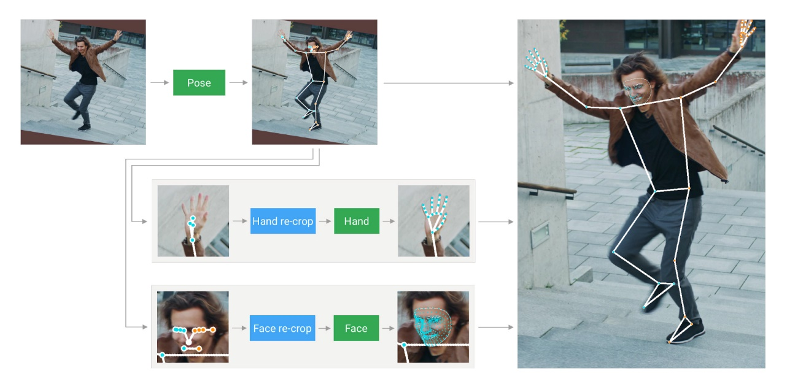This also enables the model to retain semantic consistency across the body and its parts by preventing a mixup between left and right hands or body parts of one person in the frame with another.

In addition, the resolution of the input frame to the pose model is low enough that the resulting ROIs for face and hands are still too inaccurate to guide the re-cropping of those regions, which require a precise input crop to remain lightweight. To close this accuracy gap we use lightweight face and hand re-crop models that play the role of spatial transformers and cost only ~10% of corresponding model’s inference time.

The pipeline is implemented as a MediaPipe graph that uses a holistic landmark subgraph from the holistic landmark module and renders using a dedicated holistic renderer subgraph. The holistic landmark subgraph internally uses a pose landmark module , hand landmark module and face landmark module. Please check them for implementation details.

Figure 2‑1 MediaPipe Holistic model

**Models**

* Landmark Models

MediaPipe Holistic utilizes the pose, face and hand landmark models in MediaPipe Pose, MediaPipe Face Mesh and MediaPipe Hands respectively to generate a total of 543 landmarks (33 pose landmarks, 468 face landmarks, and 21 hand landmarks per hand).

* Hand Recrop Model

For cases when the accuracy of the pose model is low enough that the resulting ROIs for hands are still too inaccurate we run the additional lightweight hand re-crop model that play the role of spatial transformer and cost only ~10% of hand model inference time.

**Solution APIs**

Cross-platform Configuration Options.

Naming style and availability may differ slightly across platforms/languages.

* STATIC_IMAGE_MODE

If set to false, the solution treats the input images as a video stream. It will try to detect the most prominent person in the very first images, and upon a successful detection further localizes the pose and other landmarks. In subsequent images, it then simply tracks those landmarks without invoking another detection until it loses track, on reducing computation and latency. If set to true, person detection runs every input image, ideal for processing a batch of static, possibly unrelated, images. Default to false.

* MODEL_COMPLEXITY

Complexity of the pose landmark model: 0, 1 or 2. Landmark accuracy as well as inference latency generally go up with the model complexity. Default to 1.

* SMOOTH_LANDMARKS

If set to true, the solution filters pose landmarks across different input images to reduce jitter, but ignored if static_image_mode is also set to true. Default to true.

* ENABLE_SEGMENTATION

If set to true, in addition to the pose, face and hand landmarks the solution also generates the segmentation mask. Default to false.

* SMOOTH_SEGMENTATION

If set to true, the solution filters segmentation masks across different input images to reduce jitter. Ignored if enable_segmentation is false or static_image_mode is true. Default to true.

* REFINE_FACE_LANDMARKS

Whether to further refine the landmark coordinates around the eyes and lips, and output additional landmarks around the irises. Default to false.

* MIN_DETECTION_CONFIDENCE

Minimum confidence value ([0.0, 1.0]) from the person-detection model for the detection to be considered successful. Default to 0.5.

* MIN_TRACKING_CONFIDENCE

Minimum confidence value ([0.0, 1.0]) from the landmark-tracking model for the pose landmarks to be considered tracked successfully, or otherwise person detection will be invoked automatically on the next input image. Setting it to a higher value can increase robustness of the solution, at the expense of a higher latency. Ignored if static_image_mode is true, where person detection simply runs on every image. Default to 0.5.

**Output**

Naming style may differ slightly across platforms/languages.

* POSE_LANDMARKS

A list of pose landmarks. Each landmark consists of the following:

* x and y: Landmark coordinates normalized to [0.0, 1.0] by the image width and height respectively.
* z: Should be discarded as currently the model is not fully trained to predict depth, but this is something on the roadmap.
* visibility: A value in [0.0, 1.0] indicating the likelihood of the landmark being visible (present and not occluded) in the image.
* POSE_WORLD_LANDMARKS

Another list of pose landmarks in world coordinates. Each landmark consists of the following:

* x, y and z: Real-world 3D coordinates in meters with the origin at the center between hips.
* visibility: Identical to that defined in the corresponding pose_landmarks.
* FACE_LANDMARKS

A list of 468 face landmarks. Each landmark consists of x, y and z. x and y are normalized to [0.0, 1.0] by the image width and height respectively. z represents the landmark depth with the depth at center of the head being the origin, and the smaller the value the closer the landmark is to the camera. The magnitude of z uses roughly the same scale as x.

* LEFT_HAND_LANDMARKS

A list of 21 hand landmarks on the left hand. Each landmark consists of x, y and z. x and y are normalized to [0.0, 1.0] by the image width and height respectively. z represents the landmark depth with the depth at the wrist being the origin, and the smaller the value the closer the landmark is to the camera. The magnitude of z uses roughly the same scale as x.

* RIGHT_HAND_LANDMARKS

A list of 21 hand landmarks on the right hand, in the same representation as left_hand_landmarks.

* SEGMENTATION_MASK

The output segmentation mask, predicted only when enable_segmentation is set to true. The mask has the same width and height as the input image, and contains values in [0.0, 1.0] where 1.0 and 0.0 indicate high certainty of a “human” and “background” pixel respectively. Please refer to the platform-specific usage examples below for usage details.

# DESIGN SIGN-LANGUAGE RECOGNITION APP FOR THE ALPHABET

## Collecting data, building and training model

### Detect Face, Hand and Pose Landmarks

We use MediaPipe holistic to be able to detect keypoint for pose, left hand and right hand:

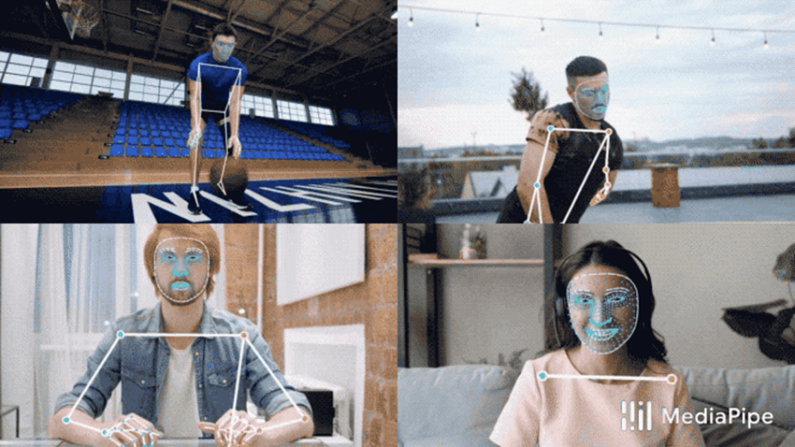

Figure 3‑1 MediaPipe

Which let to the code below:

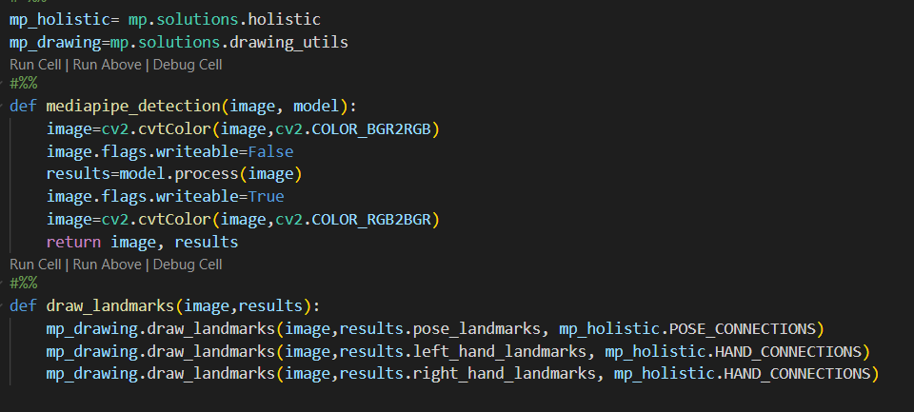

Figure 3‑2 Detect Face, Hand and Pose Landmarks

Then we use function draw_landmark() to draw the landmark points, those detected by holistic.

However, we have customized the function draw_landmark() to draw_styled_landmarks():

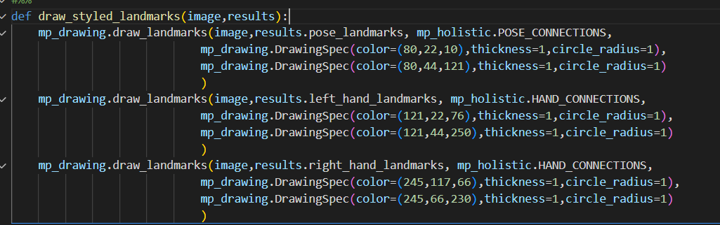

Figure 3‑3 Draw landmark

From our project:

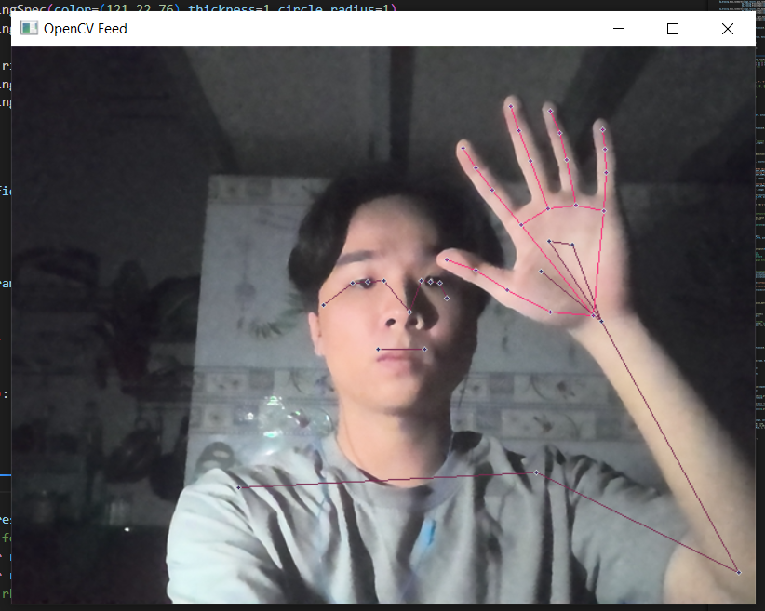

Figure 3‑4 Result of draw landmark

### Extract Keypoints

Here, we create a function call extract_keypoint(), which is use to extract the coordinates of each landmark and store them in NumPy array

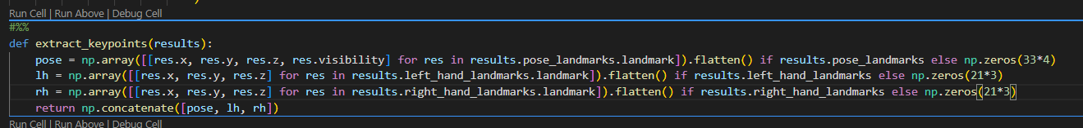

Figure 3‑5 Store key points in Numpy Array

The function returns a NumPy array store all pose, left hand and right hand keypoint coordinates from a frame

### Setup Folders for Data Collection

We create a folder name ‘MP_Data’ to store data that we would collect. Actions array is for the actions that we would detect in the project, which is 20 letters. For each action, we collect 30 videos of data, each video is 30 frame long.

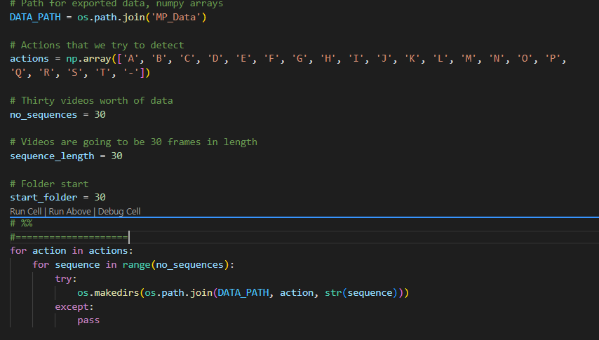

Figure 3‑6 Setup Folders for Data Collection

### Collect Keypoint Sequences

We collected the data step by step by the actions.

We pass the each frame to function ‘draw_styled_landmark()’ to draw and function ‘extract_keypoints()’ to take out the data value of each frame, and then we store them in it’s specific folder, each video is 30 frame long.

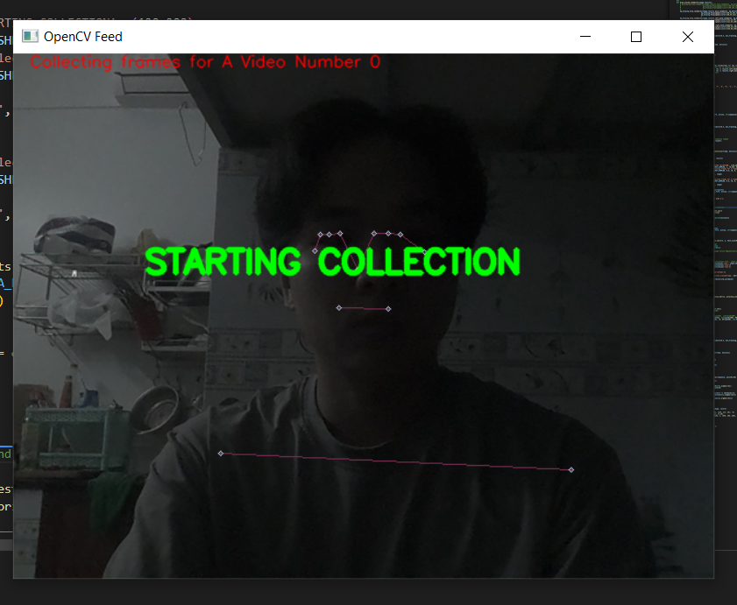

Figure 3‑7 Start Collecting data

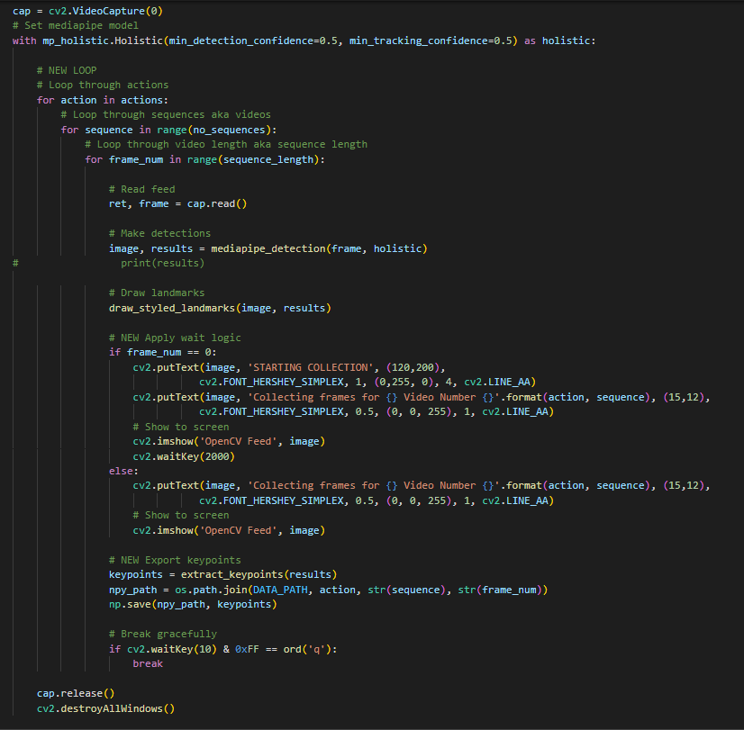

Figure 3‑8 Collection function

We create 21 actions for sign-language for 20 letters and 1 hyphen.

### Preprocess Data and Create Labels

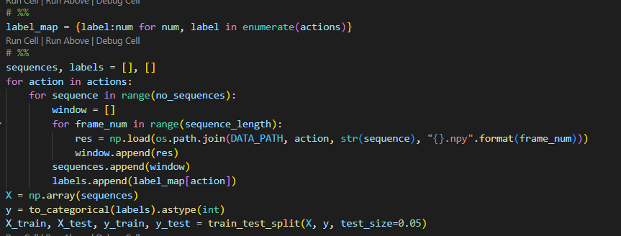

Figure 3‑9 Data loading code

In this step, we processed the data by append 30 frames of a video of an actions to one NumPy array.

Beside that, we split the train data and test data by train_test_split of sklearn library.

### Build and Train an LSTM Deep Learning Model

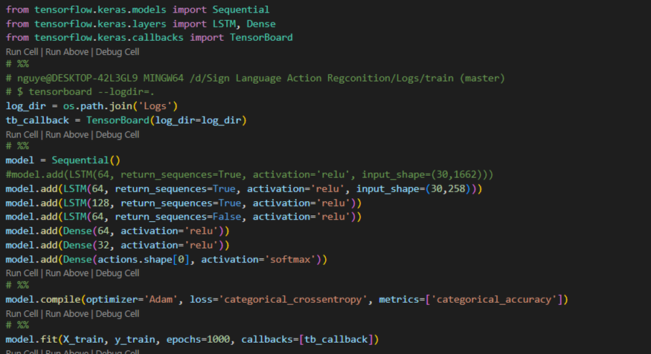

Figure 3‑10 Model definition

We use ‘Sequential’ to build sequential neural network:

Adding 3 set of LSTM model with total input shape is 30 frames, with 258 key points for each.

Adding 3 Dense layers.

Then we compile and fit model.

### Make Sign Language Predictions

By testing the predictions on the testing data, we get 100% right prediction

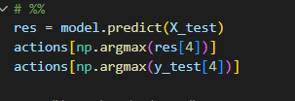

Figure 3‑11 Match result with action

### Evaluation using a Confusion Matrix

We use confusion matrix in sklearn to evaluate the model:

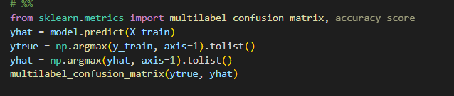

Figure 3‑12 Evaluate the model

3.1.9. Test in Real Time

At this step, we try to find out if the model work well or not:

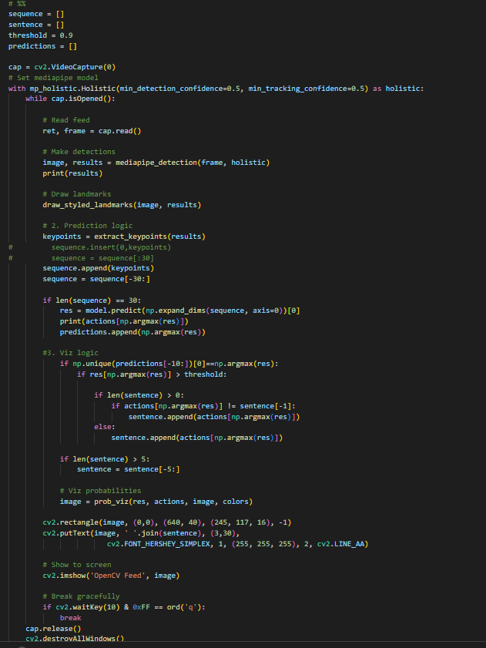

Figure 3‑13 Testing function

## Build Sign-language Recognition Application

### Idea

Project target is that the user do sign language in front of the camera in the application, the system would detect and give the predictions. Beside that, the application would give the probability for prediction of each action which user did

### Build Application

For GUI, the application use tkinter, which library is very simple and easy to design GUI.

**Camera detection:**

First, we convert the frame’s color to from BGR to RGB. Then pass the frame through mediapipe_detection to process the landmark for pose, left hand and right hand.

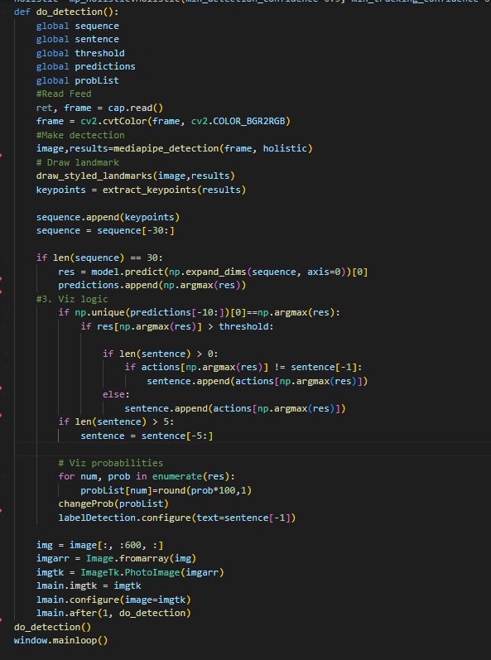

Figure 3‑14 Camera detection

After that, we use function draw_styled_landmarks() and extract_keypoints() to draw the landmark that detected to screen and extract the keypoint value for prediction.

We append keypoint of 30 frames to an array call ‘sequence’, when ‘sequence’ have 30 frame keypoint value, we will use the model that has been train to predict the actions.

**Probability for actions:**

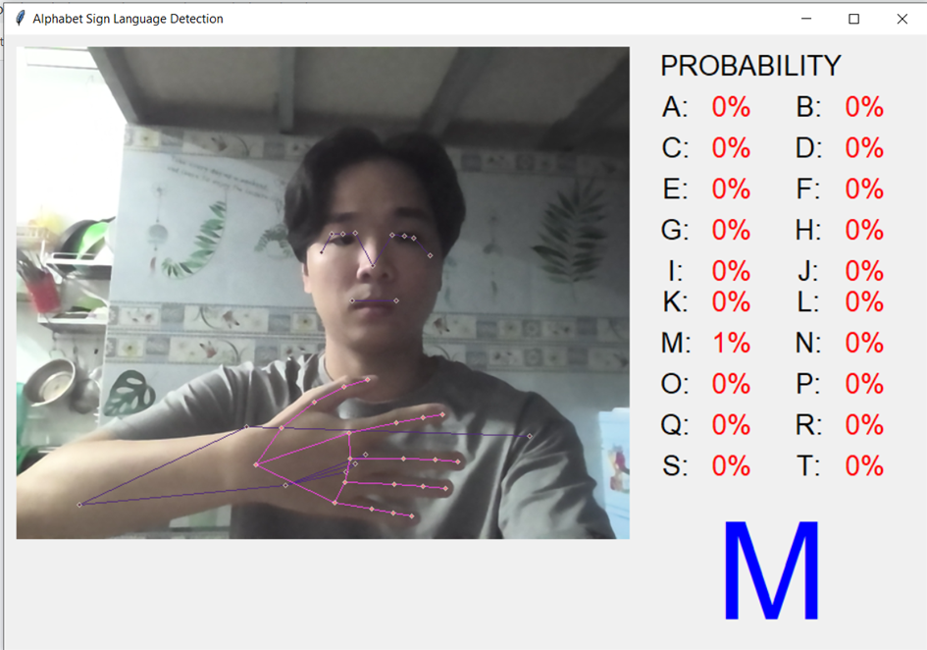

Figure 3‑15 The action for the letter M

The application would show the probability for each prediction.The values is shown by using tkinter label

The value is assigned to value of ‘probList’ NumPy array. For each of prediction of model, it would assign it’s value to the elements of the array. These value first is rounded by ‘round()’ and multiply by 100 to get to 1-100%. These elements will be assigned back to the label that show to us by the function ‘changProb()’ below:

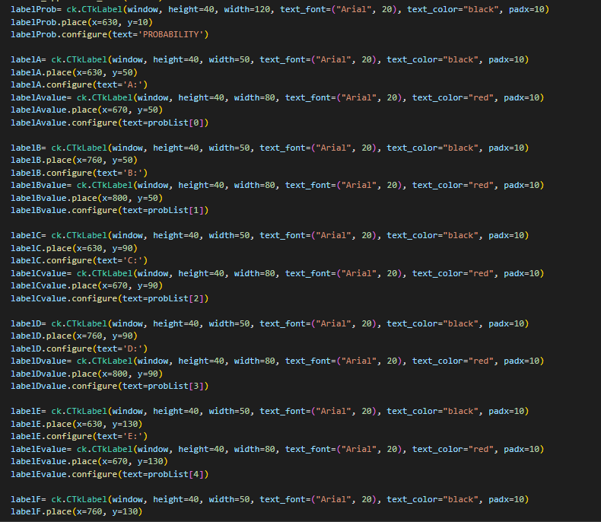

Figure 3‑16 Build window application

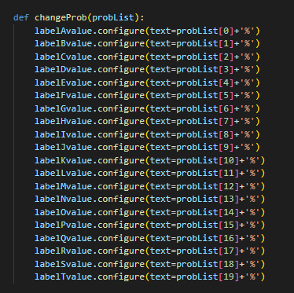

Figure 3‑17 Build probably button

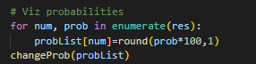

Figure 3‑18 Ressult of Problist

**Action Recognition:**



Figure 3‑19 Result Area

The right bottom corner of the application is where showing which action is detected. This is the code belong to:



Figure 3‑20 Code of result Area

As we see the below, the prediction is append to and array call sentence, the last character appended to is taking out to show in the label, which we see on screen above:

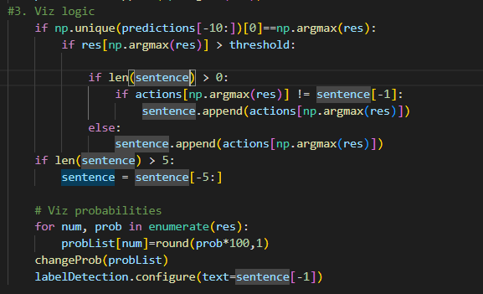

Figure 3‑21 Logic show action

# EXPERIMENT AND ANALYSIS

## Libraries and data collection:

**Libraries:**

All libraries that our project use:

1. cv2

2. NumPy

3. os

4. MediaPipe

5. tensorflow.keras

6. sklearn.metrics

7. tkinter

8. customtkinter

9. PIL

**Data collection:**

As mentioned in 3.1.4, we collect data by record video ourself and put them in folder call ‘MP_data’ in form of file .npy (NumPy array). ‘MP_data’ totally have 21 child folders: 20 letters and 1 for a hyphen (-) :

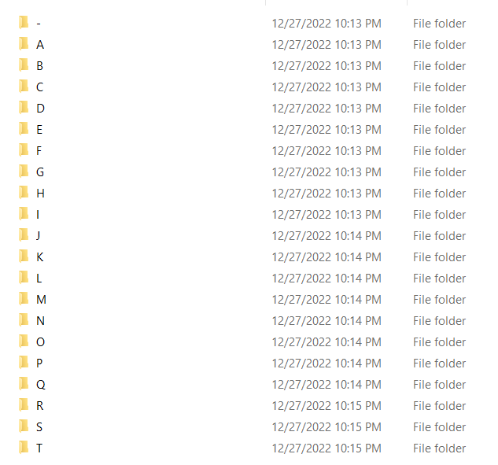

Figure 4‑1 MP_data

For each folder of actions, it contains 30 child folders,those are named from 0 to 29. Each folder has data of a video:

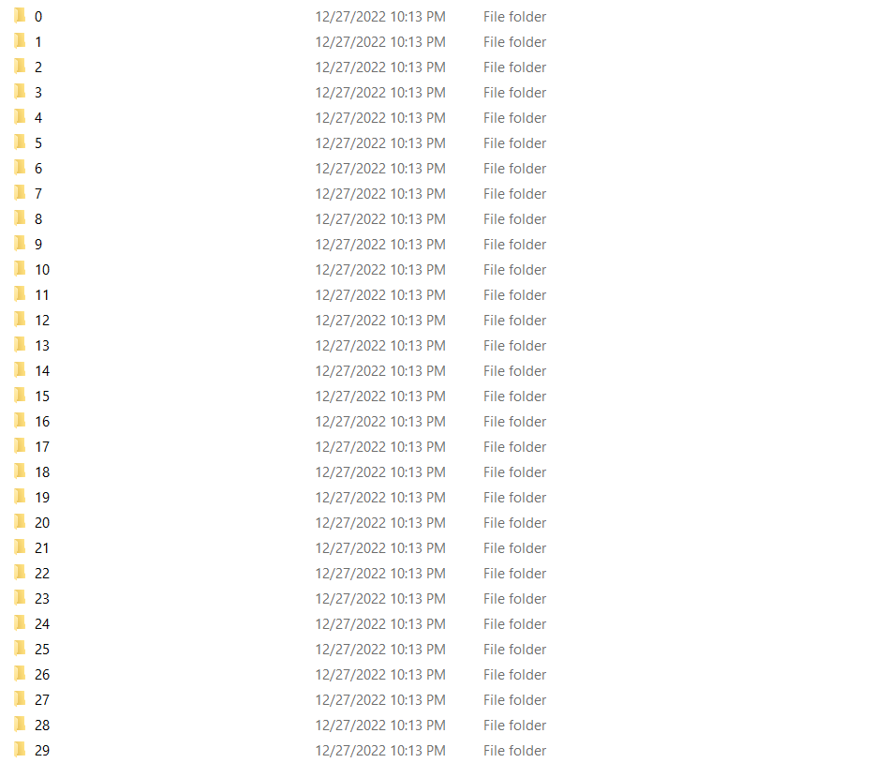

Figure 4‑2 Data set of an action

A video is 30 frames long, it is saved in 30 .npy file, preresent for each frame:

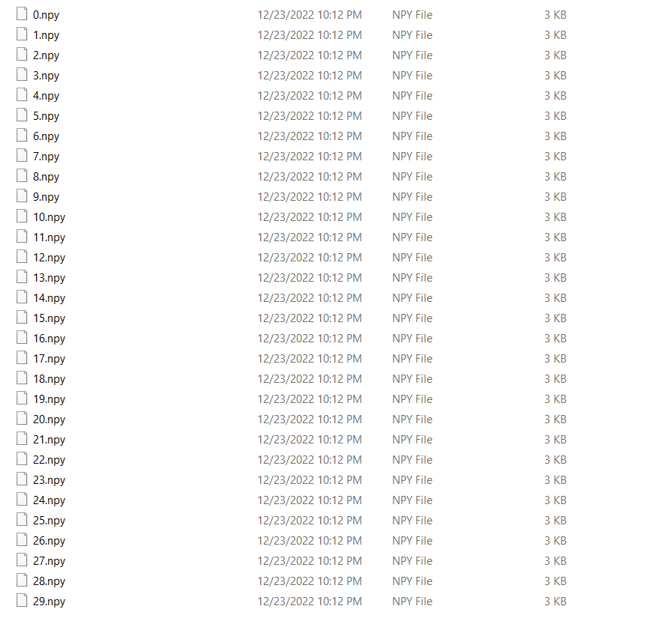

Figure 4‑3 Dataset of a video

For preparing data for training, we use an array call ‘window’ to store data of video (30 frames) and then push it to another array call ‘sequences’ respectively. Besided, we use array ‘labels’ to stores name of video actions in ‘sequences’. Array ‘sequences’ finally contains all data of 21 actions:

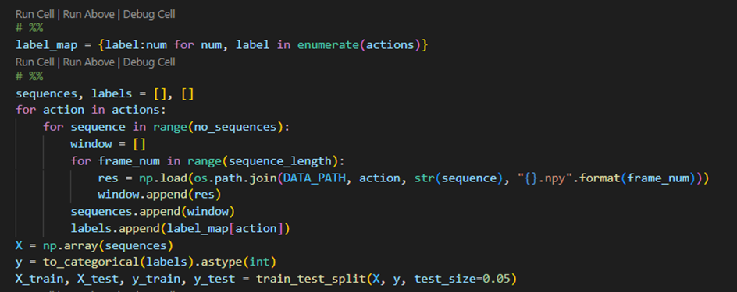

Figure 4‑4 Code to load data

We use train_test_split() to split out data for training and testing.

## Training result

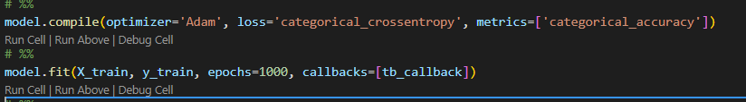

Figure 4‑5 Compile and Fit model

We train the model by 1000 epochs:

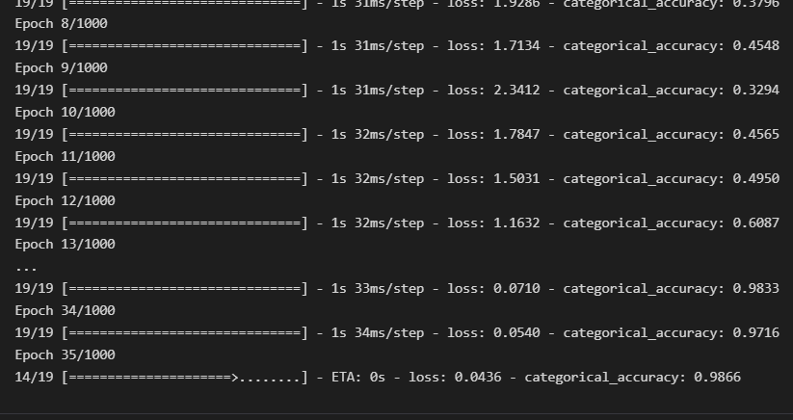

Figure 4‑6 Steps training model

We use TensorBoard to see the process of trainng by log:

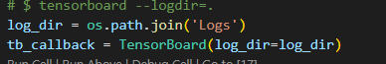

Figure 4‑7 The prossess training model

The 2 chart show the process by accuracy and epoch_loss, in the last epoch in training, the value of accuracy is 1 and epoch_loss is 0, which is a very good signal for the data training and the project.

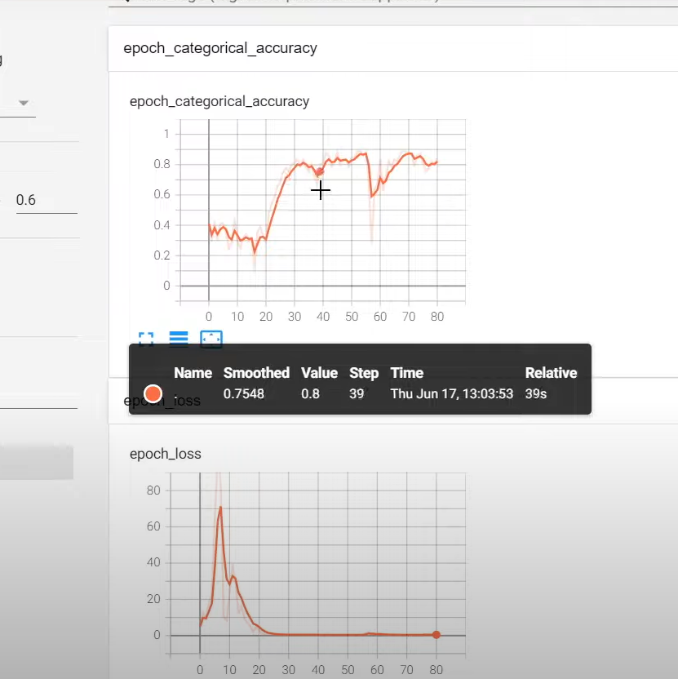

Figure 4‑8 Epoch_categorical_accuracy



Figure 4‑9 Epoch_loss

Chart showing model summary:

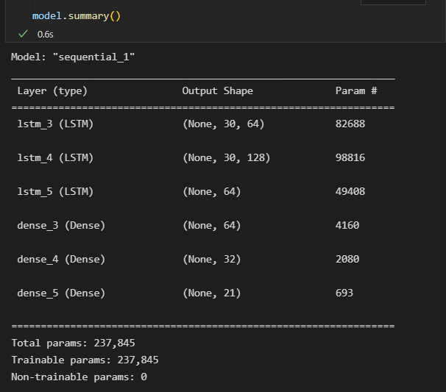

Figure 4‑10 Chart showing model summary

Then, we try to predict some actions in the test-list data:

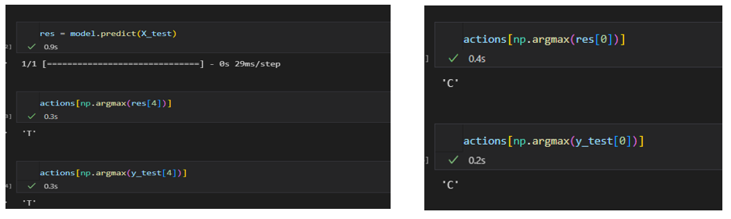

Figure 4‑11 Result after training

The result is very good.

## Evaluation using Confusion Matrix and Accuracy

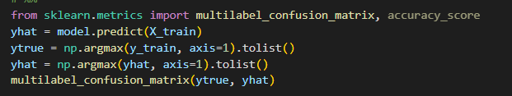

Figure 4‑12 Evaluation using Confusion Matrix and Accuracy

This is the result:

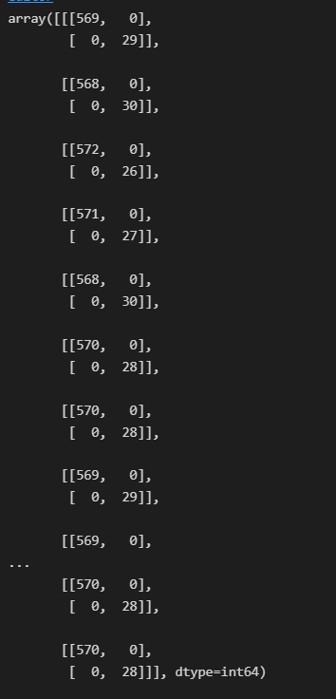

Figure 4‑13 Confusion matrix

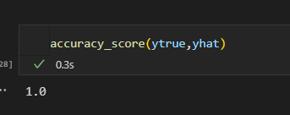

Figure 4‑14 Accuracy_score

Beside that, the accuracy_score is 1, which is a very good result.

## Testing model

In this step, we start using model to predict in real time by camera and show the prediction to screen also:

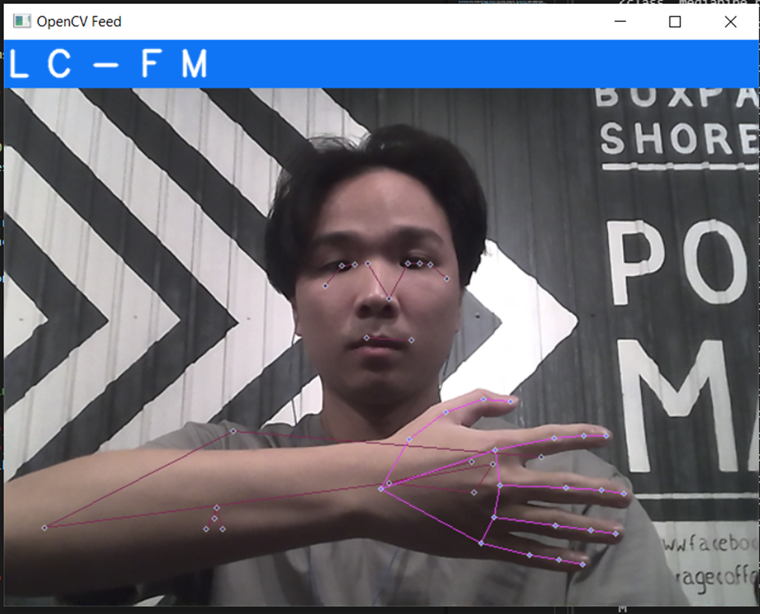

Figure 4‑15 Test model effect

The performance and testing is very well, however, the prediction is not stable. When the user is changing the action, model may detect another action by random. To improve the accuracy in prediction, we create a new array call ‘predictions’, it’s purpose is append last 10 predictions and take out the unique detect to show to the screen. As we are testing, this improves a lot in predicting accuracy.

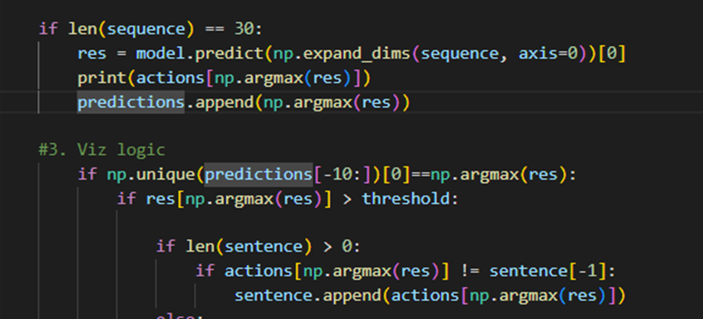

Figure 4‑16 Prediction code

## Testing the application

In this step, after the application is completed, we try to test all the actions that model has been train:

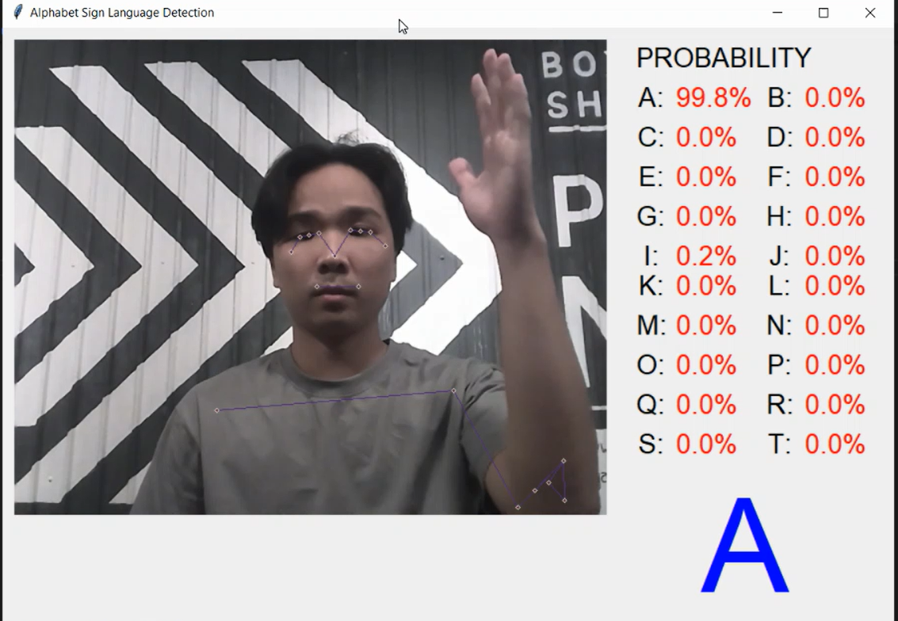

Figure 4‑17 Action A

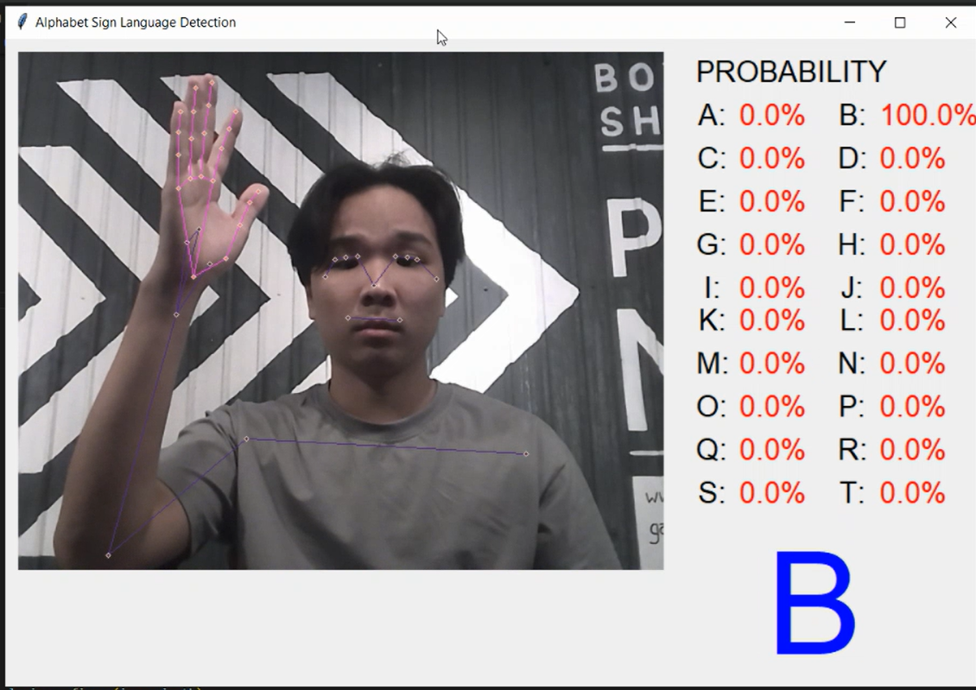

Figure 4‑18 Action B

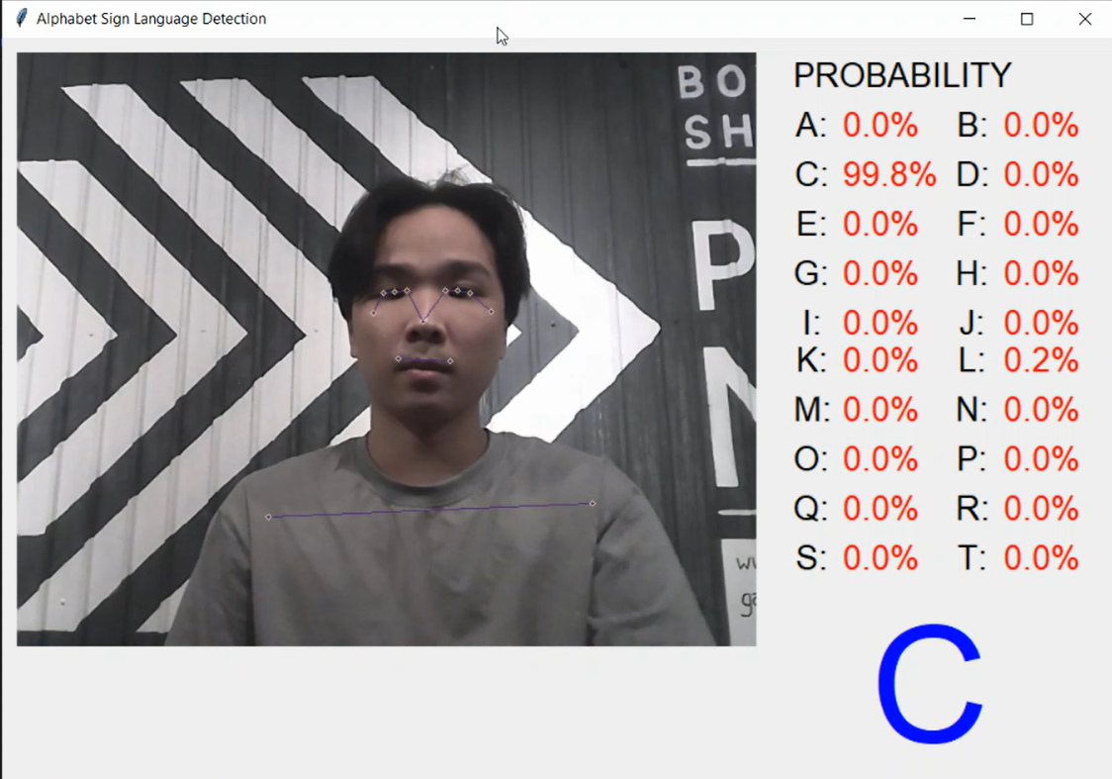

Figure 4‑19 Action C

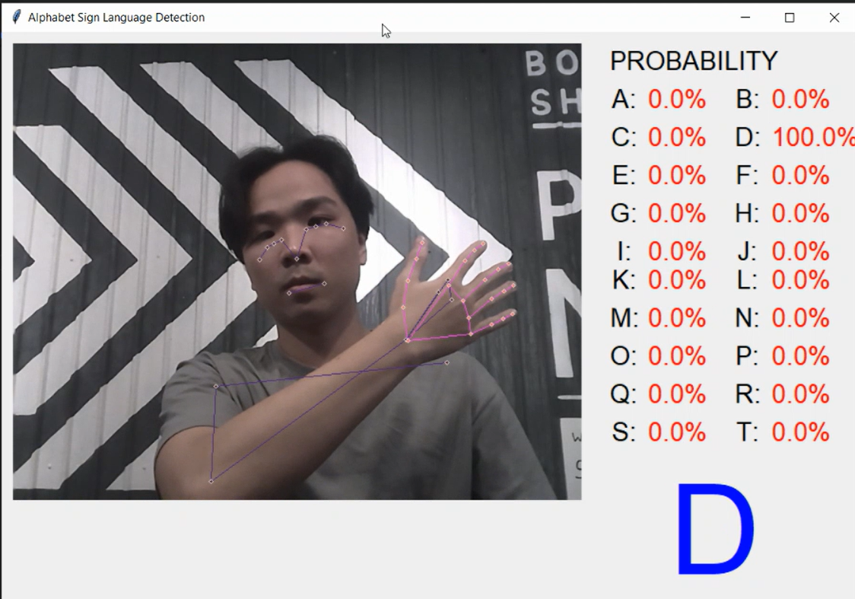

Figure 4‑20 Action D

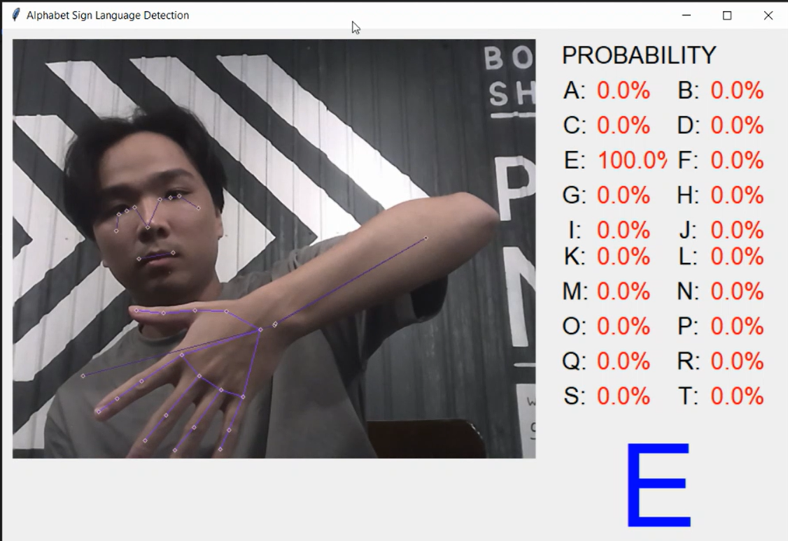

Figure 4‑21 Action E

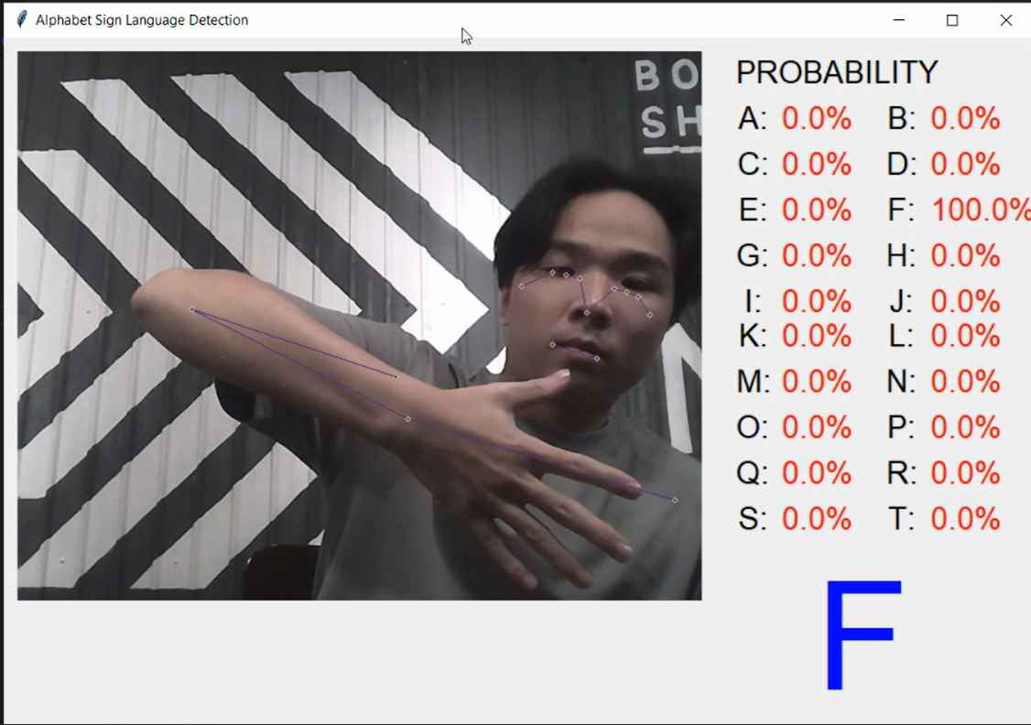

Figure 4‑22 Action F

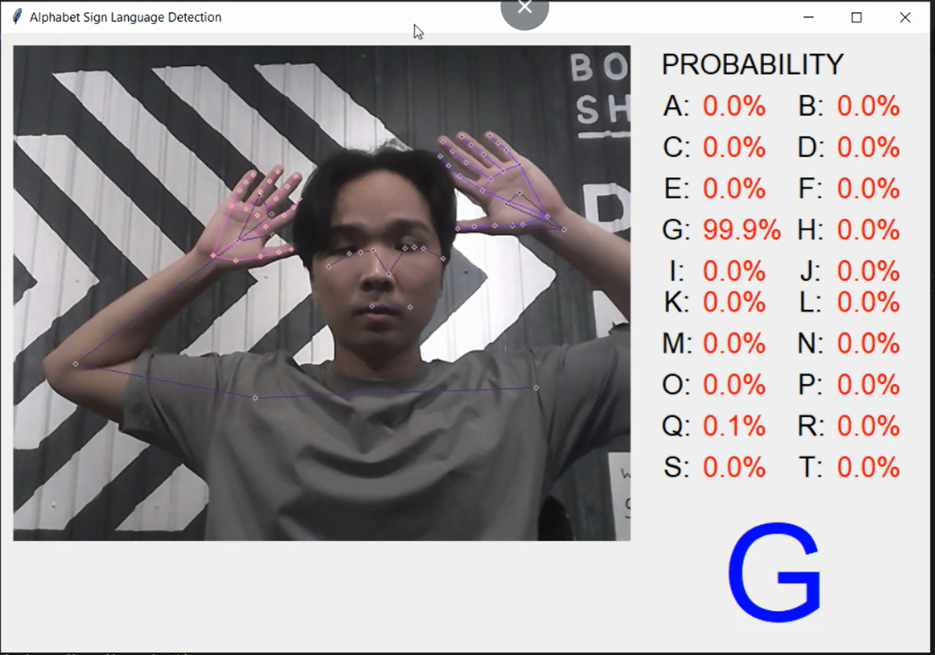

Figure 4‑23 Action G

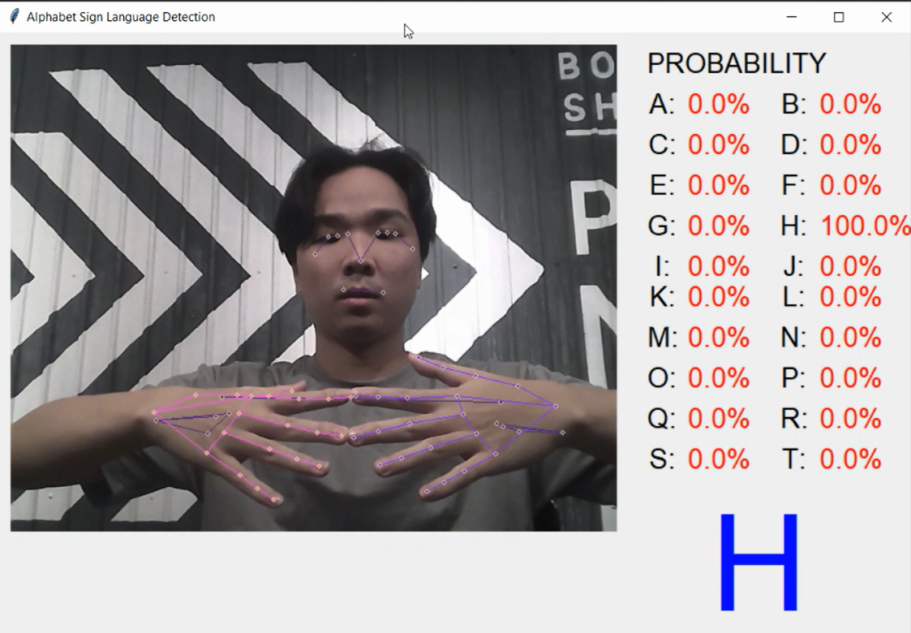

Figure 4‑24 Action H

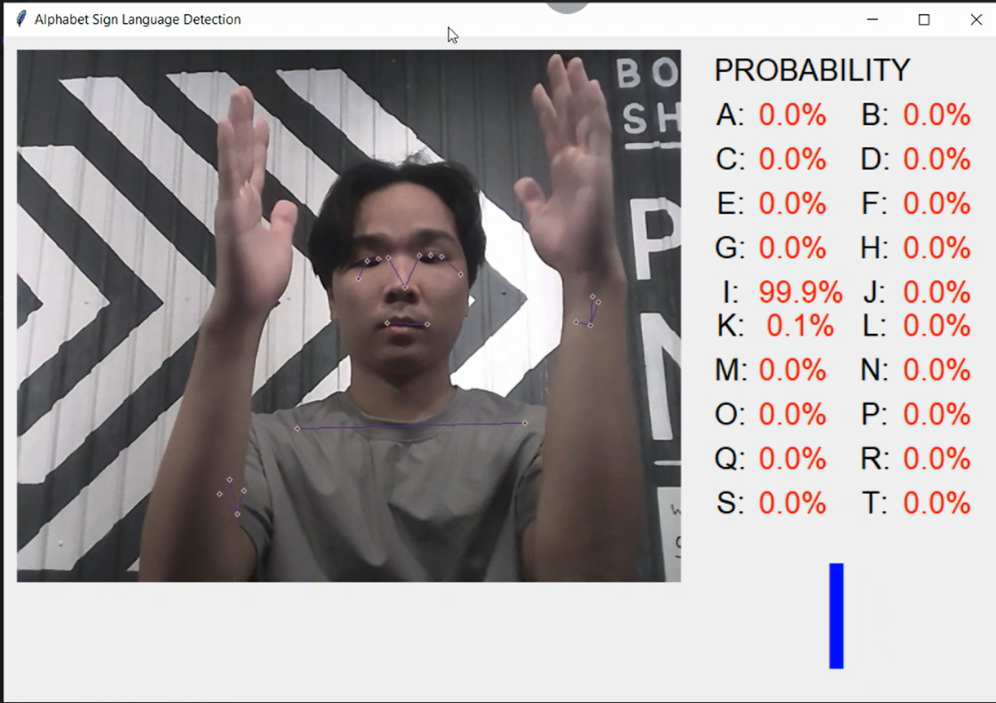

Figure 4‑25 Action I

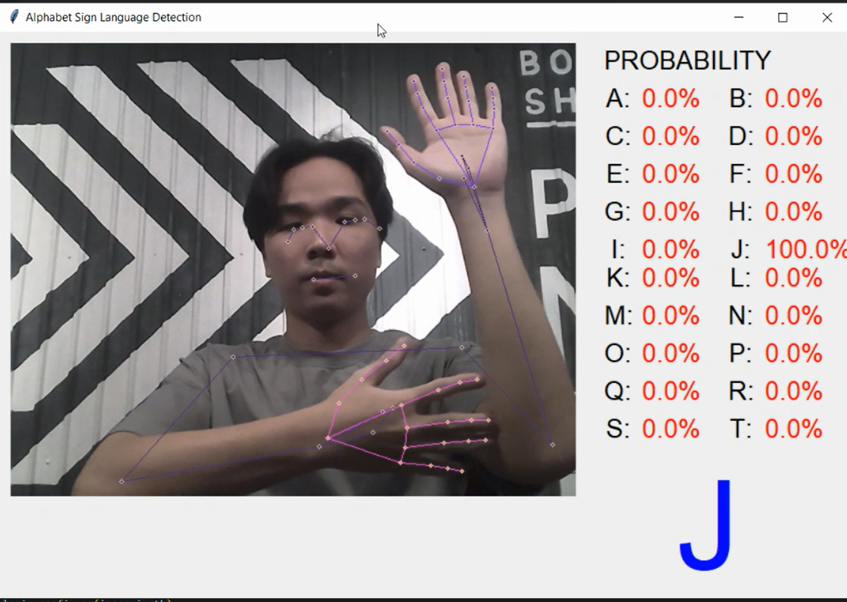

Figure 4‑26 Action J

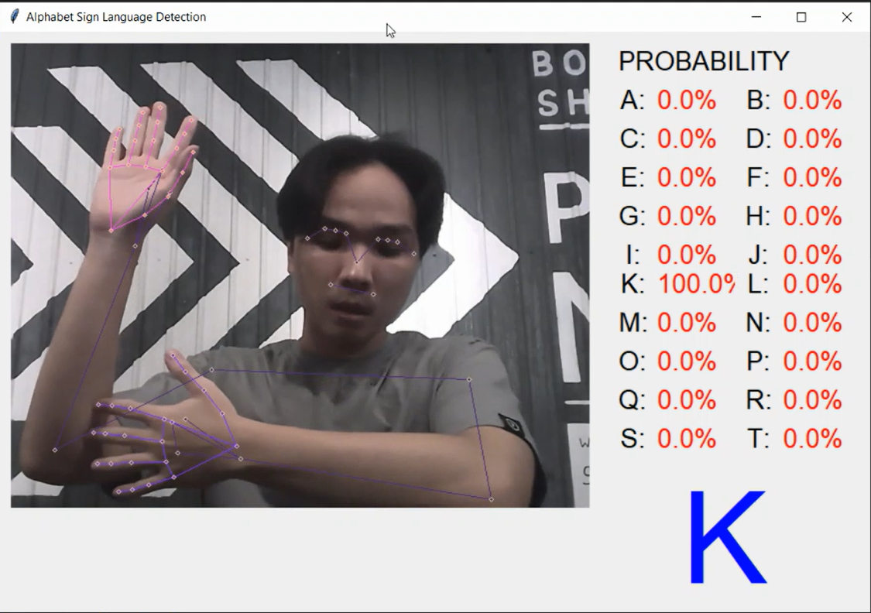

Figure 4‑27 Action K

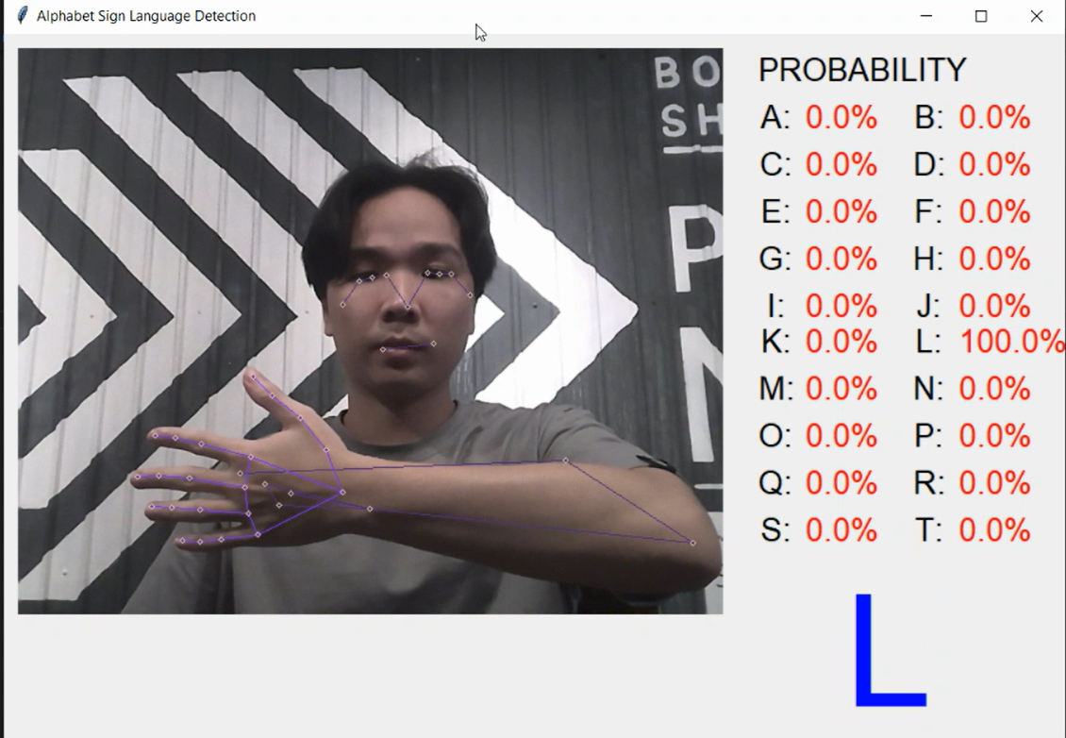

Figure 4‑28 Action L

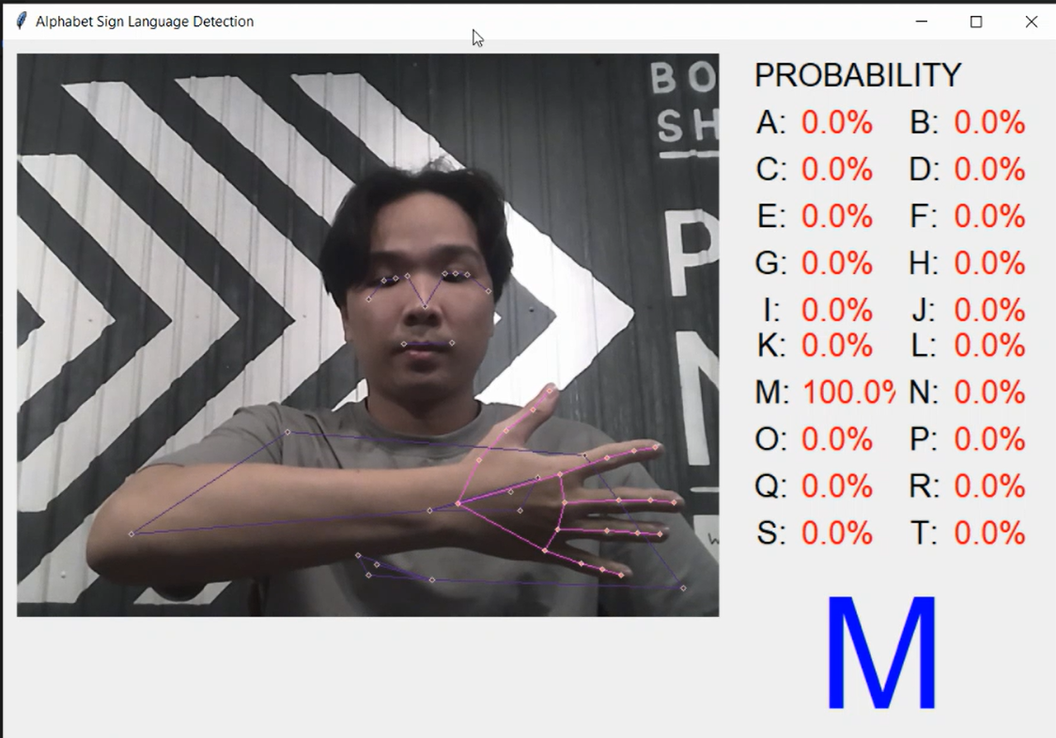

Figure 4‑29 Action M

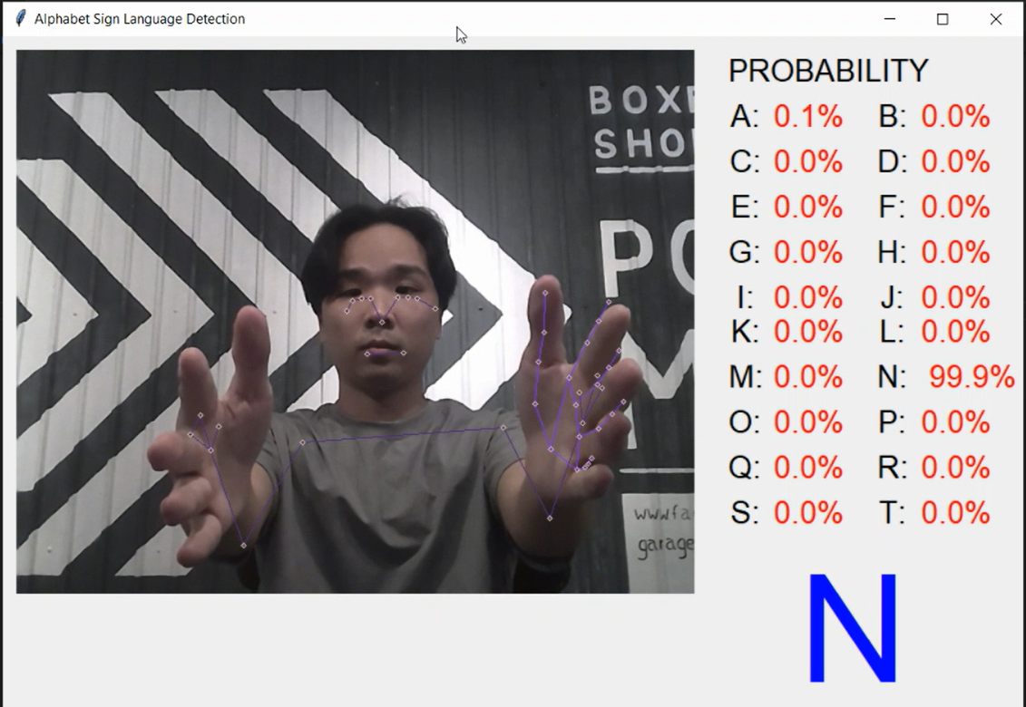

Figure 4‑30 Action N

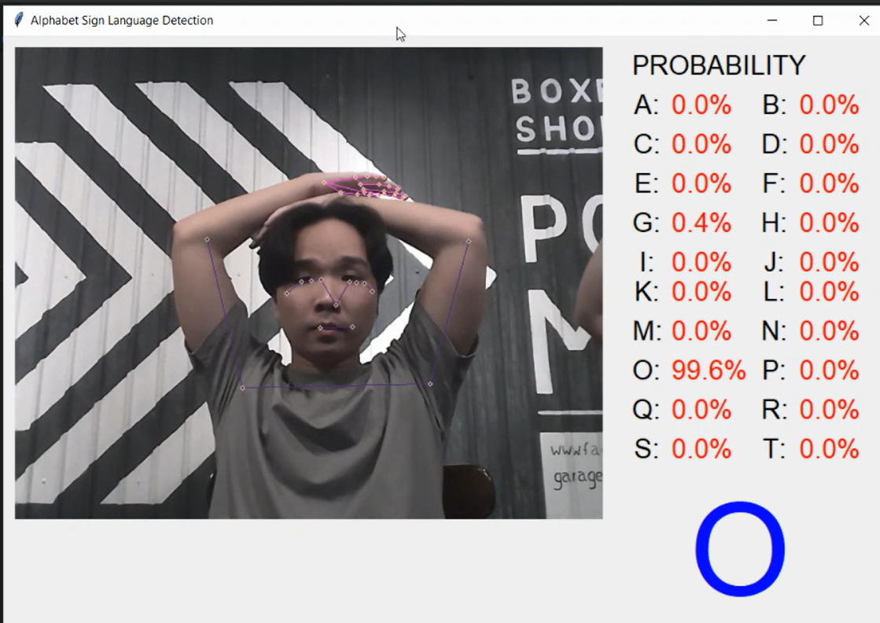

Figure 4‑31 Action O

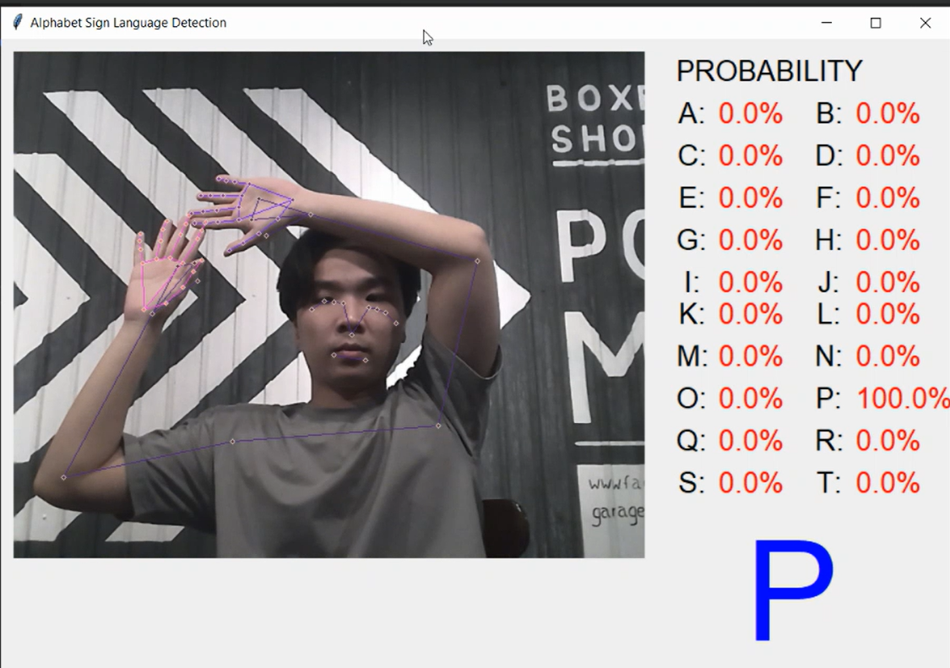

Figure 4‑32 Action P

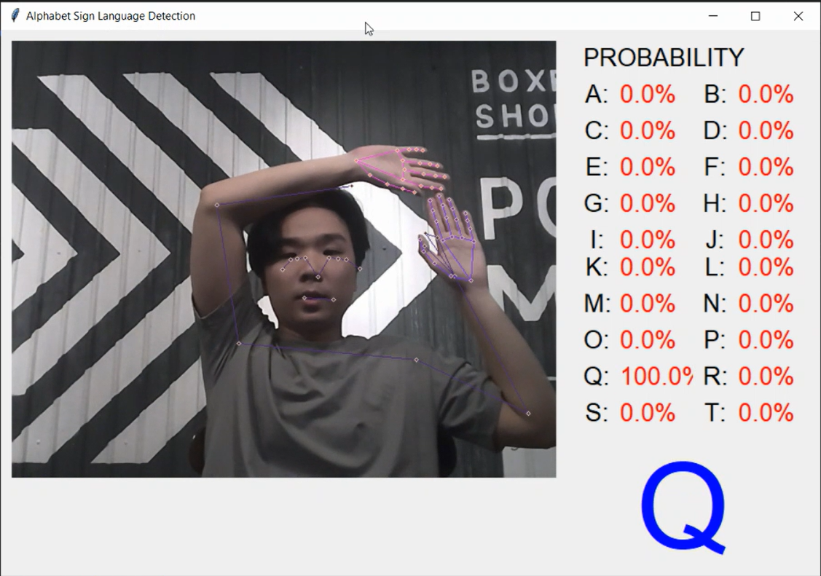

Figure 4‑33 Action Q

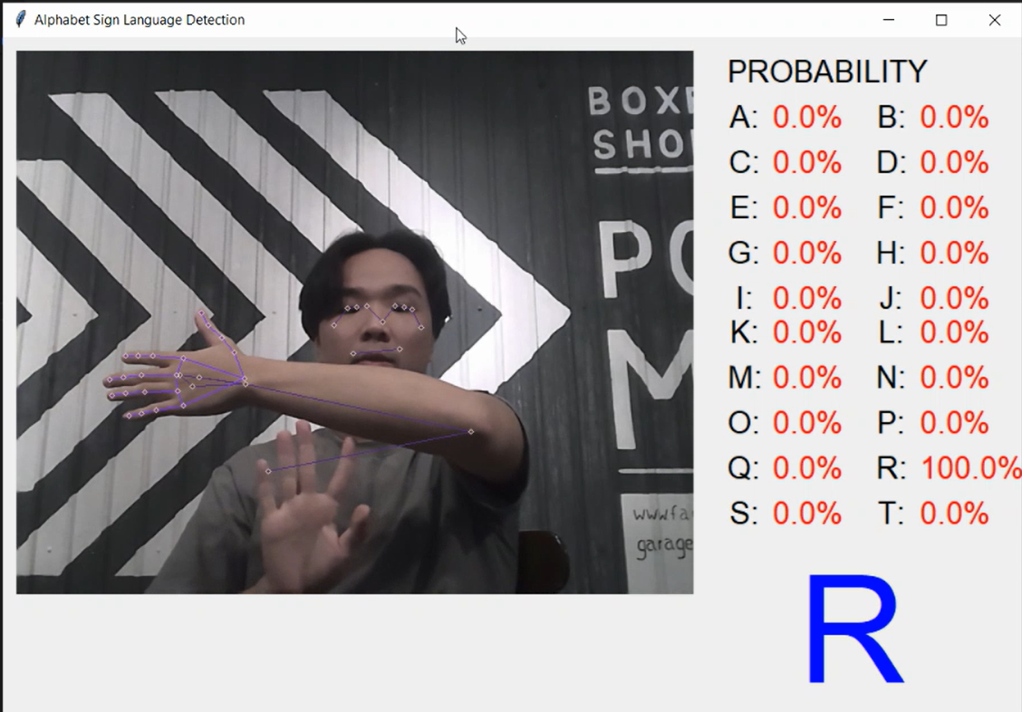

Figure 4‑34 Action R

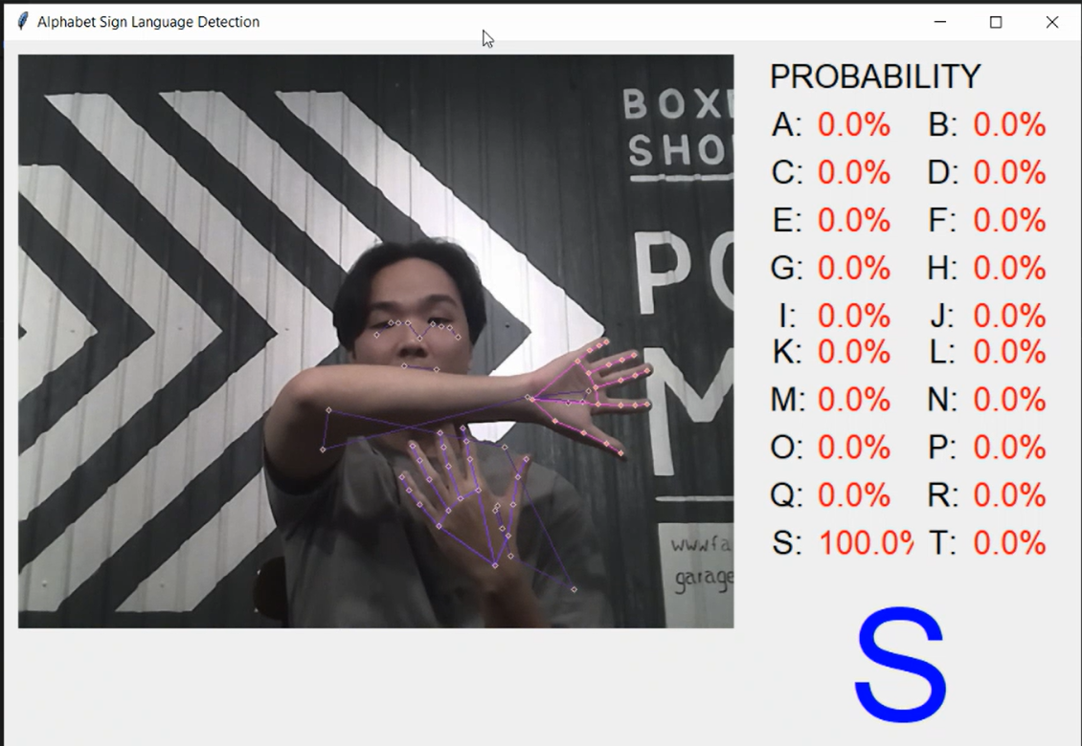

Figure 4‑35 Action S

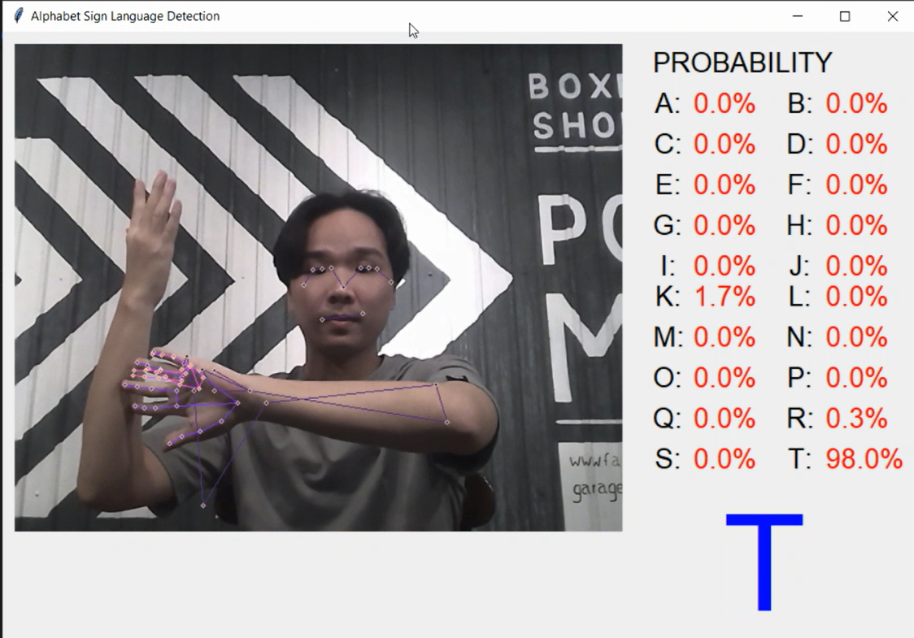

Figure 4‑36 Action T

After testing the application, we see that it work quite well, however, user need lightful environment to use or mediapipe holistic is hard to detect the landmark to extrack keypoints.

# CONCLUSION

## Evaluate project

### Advantages:

* The model works quite well.
* GUI is simple but adapt the project requirement.
* The code is clean and reusable and easy to understand.

### Limitations:

* The actions detecting are not full the Alphabet.
* MediaPipe holistic is still not work well in normal light environment, it needs a lightful environment.
* Model is still very simple.

### Development orientation

For sign language recognition, we can further create app for sign language translator, which could help the communication between normal people and the mute easier. Or just action recognition, we can create application for human management by detect what they are doing. Analyze and evaluate actions automatically by computer could help a lot in real life.

# REFERENCES

|  |  |
| --- | --- |
| [1] | David Poole and Alan Mackworth, [Online]. Available: <https://artint.info/html/ArtInt_195.html>. [Accessed 18 12 2022]. |
| [2] | A. S. 44, "GeeksforGeeks," [Online]. Available: https://www.geeksforgeeks.org/markov-decision-process/. [Accessed 19 12 2022]. |
| [3] | "Wikipedia," [Online]. Available: https://en.wikipedia.org/wiki/Principal_component_analysis. |
| [4] | "Wikipedia," [Online]. Available: https://en.wikipedia.org/wiki/Artificial_neural_network. [Accessed 15 12 2022]. |
| [5] | M. Mandal, "Analytics Vidhya," [Online]. Available: https://www.analyticsvidhya.com/blog/2021/05/convolutional-neural-networks-cnn/. [Accessed 17 12 2022]. |
| [6] | "Data Flair," [Online]. Available: https://data-flair.training/blogs/deep-learning-with-python-tutorial/. [Accessed 25 12 2022]. |
| [7] | J. Johnson, "bmc blogs," [Online]. Available: https://www.bmc.com/blogs/deep-neural-network/. [Accessed 21 12 2022]. |
| [8] | "Wikipedia," [Online]. Available: https://en.wikipedia.org/wiki/Recurrent_neural_network. [Accessed 18 12 2022]. |
| [9] | Sainath, Tara N.; Mohamed, Abdel-Rahman; Kingsbury, Brian; Ramabhadran, Bhuvana, Deep convolutional neural networks for LVCSR, 2013. |
| [10] | C. Budd. [Online]. Available: https://plus.maths.org/content/what-can-we-use-machine-learning. [Accessed 23 12 2022]. |
| [11] | "Wikipedia," [Online]. Available: https://en.wikipedia.org/wiki/RFM_(market_research). [Accessed 21 12 2022]. |

[12] Nttuan8. Neural network. <https://nttuan8.com/bai-3-neural-network/> [Accessed 15/12/2022]

[13] Support3. Python – Facial and hand recognition using MediaPipe Holistic. <https://www.geeksforgeeks.org/python-facial-and-hand-recognition-using-mediapipe-holistic/> [Accessed 28/12/2022]

[14] Fchollet. The Sequential model <The Sequential model (keras.io)/>[Accessed 21/12/2022]

[15] Simplilearn. Keras Sequential Model Explained <https://www.youtube.com/watch?v=8uC-WT1LYnU> [Accessed 18/11/2022]

[16] TensorFlow Core. <<https://www.tensorflow.org/guide>> [Accessed 20/10/2022]

[17] Simplilearn. Keras Sequential Model Explained

<https://www.youtube.com/watch?v=8uC-WT1LYnU>[Accessed 17/11/2022]

[18] Wikipedia . Sequential model <https://en.wikipedia.org/wiki/Sequential_model>[Accessed 10/12/2022]

[19] GOOGLE LLC. MediaPipe in Python<https://google.github.io/mediapipe/getting_started/python.html>[Accessed 09/10/2022]

[20] Nicholas Renotte. OpenCV for Beginners <https://www.youtube.com/watch?v=M6jukmppMqU&list=PLgNJO2hghbmg0-6EbYR3MJkHJcneXEmwx>[Accessed 14/12/2022]

[21] Nicholas Renotte. AI Pose Estimation with Python and MediaPipe <https://www.youtube.com/watch?v=06TE_U21FK4>[Accessed 07/12/2022]

[22] GOOGLE LLC. MediaPipe Holistic <https://google.github.io/mediapipe/solutions/holistic#python-solution-api>[Accessed 05/12/2022]